

DETECION OF HEALTH-RELATED MISINFORMATION USING NLP

A Project Report submitted
in fulfillment of the requirements for the degree of

MASTES IN COMPUTER APPLICATION

Submitted by

MODAR RIBA (244051026)
MCA, 6th Semester

ROYAL SCHOOL OF INFORMATION TECHNOLOGY

Under the guidance of

Nayan Jyoti Kalita

ASSISTANT PROFESSOR

ROYAL SCHOOL OF INFORMATION TECHNOLOGY
THE ASSAM ROYAL GLOBAL UNIVERSITY GUWAHATI: 781035
Session:
2024-26


CERTIFICATE OF APPROVAL

It is certified that the work contained in the report entitled "Detection of Health Related Misinformation Using NLP" by Modar Riba bearing Roll No 244051026 and Modar Riba bearing Roll No 244051026 of Modar Riba, 4th Semester under the Computer Application(IT Department), Royal School of Information Technology, The Assam Royal Global University, Guwahati, Assam for the fulfilment of the degree of Masters in Computer Application has been carried out under my supervision and that work has not been submitted elsewhere for a degree.

Project Guide: Signature of the External Examiner

Nayan Jyoti Kalita Name of the External Examiner

(Assistant Professor)

.

Date:
Place: Guwahati



FORWARDING CERTIFICATE

It is certified that the work contained in the report entitled "Detection of Health Related Misinformation Using NLP" by Modar Riba bearing Roll No 244051026 and Modar Riba bearing Roll No 244051026 of Masters in Computer Application, 4th Semester under the Computer Application(IT Department), Royal School of Information Technology, under the guidance of Nayan Jyoti Kalita, Assistant Professor has been presented in a manner satisfactory to permit its acceptance as a prerequisite to the degree for which has been submitted.

Date: Name of the HOD/ Coordinator
Place: Guwahati (Designation)

DECLARATION

I, Modar Riba bearing Roll No 244051026 hereby declare that this project work entitled “Detection of Health Related Misinformation Using NLP” was carried out by us under the guidance & supervision of Nayan Jyoti Kalita, Assistant Professor. This project work is submitted during the academic session 2024-2026. This work or no part of it has been submitted elsewhere for any other purpose till date.

Date:
Place: Guwahati

Signature

Modar Riba Modar Riba

Roll No.244051026 Roll No.244051026

ACKNOWLEDGEMENT

I take the opportunity to express my sincere gratitude to all those who supported me throughout this project/dissertation work. I am thankful for their aspiring guidance, invaluably constructive criticism and friendly advice during the project work.

I convey my special thanks to Mr. Nayan Jyoti Kalita and Mr. Pritam Deka for their support and guidance at Khyontek.ai during my project/dissertation work.

My special thanks also go to my Faculty Guide and other faculty members for their kind support for the successful completion of my project/dissertation.

Thank you

Modar Riba
Roll No 244051026

ABSTRACT

False Health Information can have many negative effects on individual and public health; the greater risk is that it could influence people’s decisions regarding their health and lead them to take harmful treatments. As a result, there is an urgent need to develop automated systems which can detect health misinformation effectively and accurately. However, identifying health misinformation automatically is challenging, especially due to the complex nature of medical claims and the scarcity of high-quality datasets that have been verified by health experts. In this project, we present and compare three different approaches for health misinformation detection: a feature-based machine learning approach (TF-IDF feature representation with Logistic Regression as the baseline), BioBERT (a transformer model pre-trained on large-scale biomedical literature), and PubMedBERT (a transformer model trained on a large corpus of PubMed abstracts). These models were trained and evaluated on a combined dataset of FakeHealth and HealthFact, which contains a total of 12,231 health claims verified by experts as either misinformation or reliable.

BioBERT achieved the highest test F1 score of 0.7970 (accuracy: 75.63%), outperforming PubMedBERT (F1: 0.7771, accuracy: 74.03%) and the TF-IDF baseline (F1: 0.7553, accuracy: 72.06%). We also exposed key precision-recall trade-offs of individual models: BioBERT offers high recall (79.95% for reliable claims) at the cost of lower precision, while PubMedBERT exhibits a more balanced trade-off between precision and recall.

Keywords: Health Misinformation, Natural Language Processing, BERT, BioBERT, PubMedBERT, Fake News Detection, social media, Deep Learning,Domain-specific Pretraining, Public Health

TABLE OF CONTENTS

Acknowledgement iv
Abstract v
List of Figures ix
List of Tables x
- Introduction
  - Background of the study 11
  - Problem Statement 11
  - Aim of the project 12
  - Objective 12
  - Scope of project 13
  - Organization structure of project 13
- Literature Review
  - Introduction 14
  - Survey and review paper 14
  - Traditional Machine Learning Methods 14
  - Multimodal and Hybrid Approach 15
  - Retrieval-Augmented and Knowledge-Based 15
  - Human-in-the-Loop and Explainability 15
  - Public Health and Intervention 15
  - Mental Health Misinformation 15
  - Literature 17
  - Summery table of key studies 18
- Research Gap And Problem Statement
  - Identified Research Gap 19
  - Problem Statement 19
- Proposed System and Methodology
  - Overview 20
  - Dataset preparation 20
  - Data preprocessing 21
  - Model Architecture 21
    - TF IDF + logistic Regression (Baseline) 21
    - BioBERT 21
    - PubMEDBERT 21
  - Model Training and Evaluation 21
  - System Integration 22
  - Prediction Workflow 22
  - Summary 22
- Tools and Technologies used
  - Introduction 23
  - Programming Language 23
  - Machine Learning Libraries 23
  - Deep Learning Framework 23
  - Data Processing Libraries 23
  - Visualization Libraries 23
  - Development Environment 24
  - Hardware and Computational Environment 24
  - Model Storage Formats 24
  - Summary
- System Implementation and Result
  - Implementation Overview 25
  - Model Performance 25
  - Overfitting Analysis 26
  - Error Analysis (Three way comparision) 27
  - Result Visualization 29
  - System validation 33
- Analysis
  - Overview of System Performance 34
  - Analysis of prediction Accuracy 34
  - Comparative Evaluation of Machine Learning and Deep Learning Models 34
  - System Effectiveness and practical Healthcare Implications 34
  - Strength of the proposed System 34
  - Limitation of the study 35
- Single Claim interference Demonstration
  - Inference pipeline 36
  - Demo on know Examples 36
  - Custom Claim Classification 40
  - Batch Inference and Confidence Analysis 20
  - Practical Use 46
- Conclusion and Future Work
  - Conclusion 47
  - Achievement of Project Objectives 47
  - Contribution of the Study 47
  - Future Work 48
  - Final Remarks 49
References 50

LIST OF FIGURES

Figure No Figure Name Page No

1. Combined Dataset Overview 25
2. Summary Statistics of the raw dataset 25
3. First Few rows of the cleaned dataset 25
4. The Three-way comparison table 25
5. Three-way Model Comparison 26
6. The eight Bucket distribution table 27
7. Eight bucket bar chart 27
8. Per Dataset Accuracy table (FakeHealth, HealthFact) 27
9. Crosstab of buckets by dataset (FakeHealth vs HealthFact) 28
10. Class Distribution of Health claims 28
11. Bar Chart shows label imbalance (misinformation vs reliable) 28
12. Baseline Model Classification report 28
13. Test set confusion matrix – TF IDF baseline 29
14. BioBERT test set classification Report 29
15. Test set confusion matrix – BioBERT 29
16. PubMedBERT test set Classification report 29
17. Test set confusion matrix – PubMedBERT 29
18. Loading the best Model 36
19. Demo on known Examples (5 claims) 36
20. Demo on known example 37
21. Batch Inference Output 37
22. Confidence distribution histogram (Correct vs incorrect) 37
23. Sample high confidence mistakes (top 10 rows) 41
24. Batch Inference output (custom claim table) 41
25. Confidence Distribution Histogram 42
26 Sample High-Confidence Mistakes(top 10rows) 42
27. Model Comparison 42
28. Performance Stats 43
29. Validation 43

LIST OF TABLES

Table No Table Name Page No

1. Summery Table of Key studies 18
2. Identify Research Gaps 19
3. Benchmark of Combined Dataset 20
4. Test Set Result (after 5 epoch) 25
5. overfitting analysis 26
6. Error analysis 27
7. Pre Dataset Accuracy 27

Chapter-1 Introduction

Background of the Study

Access to large amounts of health information on the internet has meant that millions of user can inform themselves about diseases and find advice online from other users as well as from health professionals. Users discuss their treatments and share their experiences with other experiencing similar conditions. However, health information published on the internet also contains a large amount of health-related misinformation that spreads very quickly. The World Health Organization even spoke of an “infodemic” during the public health crisis of the covid-19 pandemic – “infodemic” being a large amount of both accurate and inaccurate health information that is impossible to sift through in order to find the information that is required.

Various kinds of health-related misinformation is present on the web, like information on false cures for diseases, misinformation that increases vaccine hesitancy, misleading information on unproven health-related products that are promoted as health supplements, and various conspiracy theories related to medical facilities and the health care industry as a whole. Unlike most other forms of misinformation, or ‘fake news’, health misinformation has the potential to cause physical harm or even lead to death, in addition to other potential harmful effect to health and well-being such as keeping patients from receiving the required treatment in a timely manner due to misinformation regarding recommended treatments, and overall placing excessive stress on already overwhelmed health care systems during a crisis. Moreover, it can cause decreased trust in health care in general.

While there is a lot of false information circulating, most of it is being checked by hand by health professionals and media. However, due to the large amounts of information being published online on a daily basis by health information for accuracy.

Problem Statement
Health misinformation detection using NLP and deep learning faces many challenges despite the recent advancement in the field.
- Domain Complexity: Medical claims are difficult to verify as they are based on specific domain knowledge. General NLP models lack the required biomedical vocabulary and reasoning capabilities to process medical claims to validate their truthfulness.
- Lack of high-quality datasets: These datasets are either very small or even non-existent, because creating them costs a lot of money and usually requires a lot of medical expertise for the annotations.
- Many NLP models for health misinformation detection have been tested on very narrow datasets. For example, a model trained and tested on a large dataset of COVID-19 misinformation claims may perform very poorly on a dataset containing misinformation claims related to other health topics or even to changing claims about the COVID-19 virus.
- Evaluating Inconsistencies: In prior work, different datasets, different metrics, and even different train-test splits are used for evaluation, making it hard to compare.
- Precision‑Recall Tradeoffs: For different applications such as automated detection of potential health misinformation versus prioritization by a human expert different compromises between detecting health misinformation and generating false positives need to be made.
This project will compare and evaluate three different approaches in a systematic manner. For a consistent comparison, the same datasets and evaluation methods will be used.

Aim of the Project
The main goal of this project is to design, to develop and to evaluate a relative approach for the automatic detection of health misinformation by using NLP and deep learning techniques.

Objective
The clear objectives of this project are:
- To compile and preprocess the necessary standard datasets PubHealth and FakeHealth for health misinformation detection in the domain of health publication in a unified format for processing.
- Implement a traditional machine learning baseline based on TF‑IDF features combined with a classification using Logistic Regression for the health claims of the datasets PubHealth and FakeHealth.
- Fine-tune two domain-specific transformer models, BioBERT and PubMedBERT, for binary health claims classification.
- All three approaches are evaluated by the same set of metrics: accuracy, precision, recall and F1-score.Present a useful comparison to enable a selection of a method given a number of limitation for deployment.

Scope of the Project
In this project, we are looking at written health claims in English that have been verified.
1.Binary classification (misinformation vs. reliable)
2.Supervised learning using labeled benchmark datasets
3.Comparison of feature‑based approaches as well as general biomedical models as well as domain‑specific models based on transformers.
4.Offline evaluation using train/validation/test splits

The following are outside the current scope:
1.Multimodal detection (images, videos, audio)
2.Real‑time streaming or social media API connection
3.Multilingual or non‑English content
4.Explainability or interpretability of model predictions
5.Federated learning or privacy‑preserving techniques

Organization Structure of the Report
Chapter 1 sets out the context to the project, explains the problem under study, details the aims of the work and lists the objectives of the researcher. Chapter 2 contains a systematic review of existing research in the area. Chapter 3 outlines the research space remaining after the review, thereby outlining and structuring the problem to be addressed by the researcher. Chapter 4 sets out the proposed approach for the main for each part of the work. Chapter 5 describes in detail the tools and technologies employed throughout the body of the work, describes the datasets to be used for testing, and explains the particular model chosen results of the experiments undertaken. Chapter 7 discusses the results of the experiments, providing full interpretation where report. Chapter 6 outlines the implementation of the model using the selected tools, outlines and describes the appropriate. Chapter 8 draws to a close the researcher’s report detailing the outcomes of the study, and sets out suggestions for upcoming work.

Chapter 2

LITERATURE REVIEW

Introduction
This chapter reviews existing work on health misinformation detection that can be automated. The relevant work are categorized into several themes, i.e., survey papers, machine learning approaches, deep learning approaches, multimodal detection, retrieval-augmented detection, mental health misinformation detection, and public health intervention using misinformation detection.
- Survey and Review Paper
There are several comprehensive surveys written to map out the current state of the art in health misinformation detection. Feng et al. ( 2025) provide an up‑to‑date survey of 100 studies on health misinformation detection (2016–2025) written from a NLP perspective, including a focus on a wide range of machine learning methods, deep learning, and most recently transformer‑based methods for health misinformation detection. The authors found that most studies in the surveyed space of studies (i.e. 100 studies reviewed) rely heavily on a small set of COVID‑19 datasets. Moreover, the surveyed space of studies suffer from several limitations, including (1) a lack of generalization to languages other than English and (2) a lack of sufficient explainability for the detected health misinformation. The authors note that, recently, there are emerging new types of health misinformation, i.e. health misinformation that are generated by AI systems. Therefore, there is a pressing need for developing novel methods to detect health misinformation generated by AI systems.
Schlicht et al. (2023) conducted a systematic review on 43 studies and presented a taxonomy for the described methods in a structured manner. The majority of detection approaches for health misinformation are based on deep learning, especially on pre-trained transformers such as BERT and DistilBERT, which in many cases clearly outperform classical methods. Nevertheless, several big challenges such as dataset heterogeneity, imbalanced classes and missmatched annotations still have to be overcome by the currently developed detection approaches.
Su et al. ( 2020) in their survey paper for the misinformation detection from health perspective provided an overview on how NLP can be used to fight health misinformation. The paper analyzes different linguistic characteristics or cues which are being used for feature representation, various models that have been employed to carry out health misinformation detection, and finally an exhaustive analysis of different metrics which are used for evaluation. The authors concluded that health misinformation detection can be carried out effectively by employing hybrid multi‑source, multi‑modal and multi‑facet inference based approaches.

Traditional Machine Learning Methods
Before the dominance of transformers, health misinformation detection relied on feature engineering and classical classifiers. TF-IDF vectors, n-grams, and linguistic features were commonly used with SVM, Logistic Regression, Random Forest, and Naive Bayes.
Cabral et al. (2021) introduced FakeWhatsApp.BR, a dataset of Brazilian Portuguese WhatsApp messages, and evaluated TF-IDF with n-grams (uni-, bi-, tri-grams) and multiple classifiers. The best configuration achieved an F1-score of 0.73, rising to 0.87 when filtering very short texts. Bigrams and trigrams significantly improved performance.
- Multimodal and Hybrid Approach
Hou et al. (2019) developed a multimodal approach combining linguistic, acoustic, and user engagement features to detect misinformation in prostate cancer-related YouTube videos, achieving 74% accuracy. Linguistic features contributed most significantly.
et al. (2025) proposed MultiTec, a multimodal framework for detecting healthcare misinformation in TikTok short videos, integrating textual captions, audio signals, and visual frames. Results showed significant performance gains compared to unimodal baselines.
Sikosana et al. (2024) evaluated hybrid models that combine TF-IDF features with neural embeddings and classifiers such as CNN and LSTM, showing that hybrid architectures outperform standalone traditional models.
- Retrieval-Augmented and Knowledge-Based
Taib et al. (2025) proposed a chunking mechanism integrated into a Retrieval-Augmented Generation (RAG) framework, achieving 70.10% accuracy, 89.8% recall, and an F1-score of 0.767. RAG significantly boosted recall but introduced more false positives.
Rostami & Hawamdeh (2025) investigated the use of debunk lists (structured external knowledge) to improve LLM performance, showing F1-score improvements between 2.63% and 11% across multiple LLMs.
- Human-in-the-Loop and Explainability
Nabożny et al. (2022) proposed a human-in-the-loop framework that automatically identifies highly credible statements, allowing medical experts to focus on non-credible content. The framework achieved high precision (83.5%-98.6%) and more than doubled expert efficiency. They also incorporated LIME for explainability.
Kamali et al. (2024) introduced a detection approach based on identifying
persuasive communication strategies, integrating these features into language models to improve detection performance and explainability.
- Public Health and Intervention
Malek et al. (2025) proposed an automated framework combining BERT classification with BERTopic topic modeling to detect, analyze, and refute COVID-19 misinformation, achieving 98% classification accuracy.
Alsmadi et al. (2022) evaluated multiple ML and NLP techniques for COVID-19 misinformation detection, showing that sentence-transformer models (BERT) significantly improve performance and that combining multiple datasets helps balance class distributions.
- Mental Health Misinformation
Köckritz et al. (2025) reviewed NLP applications in news media and mental health contexts, highlighting challenges in detecting subtle misinformation and emotionally manipulative content.
Yang et al. (2025) developed a credibility assessment framework and deep learning models (BERT, GRU, RoBERTa) to detect mental health misinformation on social media. BERT and GRU performed well in capturing linguistic cues of trustworthiness, though models struggled with complex contextual reasoning.

- Literature
The reviewed literature confirms that:
- Domain-specific pretraining (BioBERT, PubMedBERT) generally outperforms general-purpose models.
- Most studies focus on single datasets, limiting generalizability claims.
- Precision-recall tradeoffs are rarely discussed in deployment contexts.
- Overfitting is a recognized risk, especially with small, expert-annotated datasets.
- There is no consensus on best practices for evaluation protocol
- Summary Table of Key Studies

Ref. | Paper | Dataset | Method | Result | Limitation
1 | Feng et al. (2025) | Review of health misinformation detection studies | Survey of approaches, challenges, and opportunities in ML/NLP misinformation detection | Identifies key trends in detection, explainability, datasets, and deployment | Review paper only; no new model or benchmark dataset
2 | Schlicht et al. (2023) | Multiple health misinformation studies | Systematic review of automatic detection methods | Summarized common datasets, methods, and evaluation trends | Dataset imbalance and limited generalizability across platforms
3 | Blanco-Fernandez et al. (2024) | Spanish misinformation dataset | Deep learning for Spanish misinformation detection | Improved detection in Spanish-language misinformation tasks | Language-specific; may not generalize to English or multilingual data
4 | Su et al. (2020) | Social media misinformation datasets | Review of motivations, methods, and metrics | Categorized misinformation detection approaches and evaluation measures | Broad review; limited model-level experimentation
5 | Nabozny et al. (2022) | Medical misinformation examples | Human-in-the-loop misinformation detection | Improved efficiency of medical experts during review | Depends on expert feedback and curated examples
6 | Hou et al. (2019) | Online medical videos | Automated detection using text and video-related features | Demonstrated feasibility of detecting misinformation in medical videos | Focused on video content; limited transfer to short text claims
7 | Nigam et al. (2021) | Indian misinformation examples | NLP and deep learning approaches | Explored misinformation detection in the Indian context | Region-specific and limited dataset scale
8 | Cabral et al. (2021) | FakeWhatsApp.BR | NLP classification for WhatsApp misinformation | Provided a dataset and baseline detection models | Portuguese-specific and platform-specific language patterns
9 | Sun et al. (2025) | Medical misinformation literature | Scoping review of NLP methods | Mapped NLP applications for medically inaccurate information | Review-based; does not introduce a deployable classifier
10 | Malek et al. (2025) | Health misinformation intervention data | LLM-based intervention and evaluation | Showed potential of LLMs for misinformation response | LLM outputs require careful validation and safety checks
11 | Hossain et al. (2020) | COVIDLIES | COVID-19 misconception classification | Introduced a benchmark for COVID misinformation detection | COVID-specific; less coverage of general health claims
12 | Papanikou et al. (2025) | Social network misinformation data | Analysis of misinformation spread in health networks | Studied patterns of health misinformation circulation | Social network dependent; limited claim-level classification focus
13 | Khemani et al. (2024) | Health misinformation datasets | Machine learning / NLP classification | Detected misinformation using automated text-based methods | May struggle with nuanced or borderline medical claims
14 | Padalko et al. (2025) | Health misinformation data | Comprehensive detection framework | Proposed broader pipeline for misinformation detection | Framework complexity may limit simple deployment
15 | Sikosana et al. (2024) | Health misinformation data | Hybrid model comparison | Compared hybrid approaches for classification | Performance depends on dataset quality and feature design
16 | Cianciulli et al. (2025) | Digital health misinformation studies | Review of AI and digital technologies | Discussed AI tools for combating health misinformation | High-level review; limited experimental validation
17 | Kockritz et al. (2025) | News and mental health misinformation | NLP analysis of misinformation and mental health content | Examined misinformation in mental health news contexts | Domain-specific to mental health/news media
18 | Taib et al. (2025) | Health misinformation dataset | Chunking strategy with transformer-based detection | Improved detection using structured chunking | Depends on text length and chunking design
19 | Alsmadi et al. (2022) | COVID misinformation data | Automated fake COVID misinformation detection | Classified COVID misinformation using ML/NLP | COVID-specific and may not generalize to broader health misinformation
20 | Kamali et al. (2024) | Persuasive misinformation content | Persuasive writing strategy analysis | Identified persuasive patterns in misinformation | Focuses more on persuasion than full claim verification
21 | Shang et al. (2025) | MultiTec dataset | Multimodal / multilingual misinformation detection | Proposed a dataset for broader misinformation analysis | Dataset and method complexity may require more resources
22 | Malek et al. (2025) | Health misinformation framework data | Methodology framework for intervention | Proposed structured process for misinformation intervention | More methodological than model-performance focused
23 | Rostami & Hawamdeh (2025) | Debunk lists | Analysis of fact-checking/debunking resources | Studied debunk lists for misinformation tracking | Relies on existing debunked claims; may miss new misinformation
24 | Hussna et al. (2024) | Infodemic-related misinformation data | Analysis of misinformation spread | Investigated patterns within health infodemics | Focused on analysis rather than deployable classification
25 | Yang et al. (2025) | Mental health misinformation data | Characterization and evaluation methods | Evaluated mental health misinformation characteristics | Domain-specific; limited coverage of general medical claims

Chapter 3
RESEARCH GAP AND PROBLEM STATEMENT
- Identified Research Gaps
Based on the systematic literature review, the following research gaps were identified:

Gap Area | Description
Dataset Limitation | Most studies rely on narrow, English-only, COVID-19-focused datasets.
Lack of Comparative Studies | Direct comparisons between TF-IDF, BioBERT, and PubMedBERT on identical splits are rare.
Overfitting Underreporting | Many studies report only test set performance without analyzing dev-test gaps.
Precision-Recall Neglect | Tradeoffs between precision and recall are seldom discussed in relation to deployment scenarios.
Domain Alignment Question | It remains unclear whether BioBERT or PubMedBERT is superior for health misinformation specifically (not just biomedical NLP in general).

- Problem Statement
This project addresses the following research questions:
- RQ1: How do TF-IDF + Logistic Regression, BioBERT, and PubMedBERT compare in accuracy, precision, recall, and F1-score for health misinformation detection?
- RQ2: Which models show signs of overfitting when comparing development to test set performance?
- RQ3: What are the precision-recall tradeoffs among models, and how do they inform deployment decisions?
- RQ4: Does domain-specific pretraining on PubMed abstracts (PubMedBERT) provide an advantage over general biomedical pretraining (BioBERT) for this task?

Chapter 4
PROPOSED SYSTEM AND METHODOLOGY

- Overview
The proposed methodology follows a systematic pipeline: dataset collection and preprocessing, model implementation (baseline + two transformer models), training and validation, and comparative evaluation using multiple metrics.
- Dataset Preparation
Two benchmark datasets were combined and preprocessed:
Dataset | Source | Description
FakeHealth | News articles and social media posts | 2,156 articles with expert-verified labels
HealthFact | Fact-checked health claims | 12,266 claims labeled TRUE / FALSE / MIXTURE / UNPROVEN

The combined raw dataset contained 14,422 rows. After cleaning — which included removing rows with missing binary labels, standardising labels to 0 = misinformation and 1 = reliable, deduplicating records, and discarding rows where the text was empty — the final processed dataset had 12,231 rows.
The label distribution in the cleaned dataset is:
Reliable (class 1): 7,542 claims
Misinformation (class 0): 4,689 claims
The dataset includes a split column from HealthFact (train / dev / test). FakeHealth does not have predefined splits, so a stratified split was applied: 70% train, 15% dev, 15% test, preserving the original label distribution.
Objective 1 accomplished: The compilation and preprocessing of the FakeHealth and HealthFact datasets into a unified format (12,231 cleaned rows, standardised binary labels) has been completed as described above.
- Data Preprocessing
- Text cleaning: Whitespace normalization, special character removal.
- Label standardization: Binary conversion (0/1).
- Deduplication: Removal of duplicate records based on dataset and record_id.
- Train/validation/test split: Combined splits – original HealthFact splits (train/dev/test) preserved; FakeHealth split into 70% train, 15% dev, 15% test, stratified by label. Final splits: train 9,588, dev 1,332, test 1,311 samples.
- Model Architectures
4.4.1 TF-IDF + Logistic Regression (Baseline)
- TF-IDF vectorizer with n-grams (1,2), max features = 30,000, min_df = 2, stop words = ‘english’.
- Logistic Regression with max_iter=2000, class_weight='balanced', random_state=42.
- Pipeline using scikit-learn.
Objective 2 accomplished: The traditional machine learning baseline (TF-IDF with Logistic Regression) has been successfully implemented.
4.4.2 BioBERT
- Pre-trained model: dmis-lab/biobert-base-cased-v1.1
- Sequence length: 256 tokens
- Binary classification head
- Fine-tuned for 3 epochs
- Batch size: 4 with gradient accumulation steps = 2 (effective batch size 8)
- Learning rate: 2e-5, warmup ratio = 0.1, weight decay = 0.01
Objective 3 (BioBERT part) accomplished: The BioBERT transformer model has been fine-tuned for binary health claim classification.
4.4.3 PubMedBERT
- Pre-trained model: microsoft/BiomedNLP-PubMedBERT-base-uncased-abstract-fulltext
- Sequence length: 256 tokens
- Binary classification head
- Fine-tuned for 3 epochs
- Same hyperparameters as BioBERT for fair comparison
Objective 3 (PubMedBERT part) accomplished: The PubMedBERT transformer model has been fine-tuned for binary health claim classification.
- Model Training and Evaluation
All transformer models were trained using the HuggingFace Trainer API. Evaluation metrics:
- Accuracy: Overall correctness
- Precision: Positive predictive value (for class 1 – reliable)
- Recall: True positive rate (for class 1)
- F1-score: Harmonic mean of precision and recall
Models were evaluated on both development and test sets. The best model was selected based on development F1-score.
- System Integration
All models were integrated into a comparative framework using Python scripts and Jupyter notebooks. Results were saved as CSV files and JSON metrics for later analysis.
- System Implementation
The project was implemented in Python using:
- Data processing: Pandas, NumPy
- Baseline: Scikit-learn
- Transformers: HuggingFace Transformers, PyTorch
- Environment: CPU (due to resource constraints) – training times were longer than GPU but feasible with reduced batch sizes.
- Prediction Workflow
- Load preprocessed dataset.
- Split into train/dev/test consistently.
- Train baseline model and transformer models.
- Evaluate on dev and test sets.
- Collect predictions and probabilities.
- Perform three-way comparison and error analysis.

4.9 Summary
The methodology successfully integrates traditional machine learning and domain-specific transformer models into a unified comparative framework, ensuring fair comparison through identical splits and hyperparameters.

Chapter 5
TOOLS AND TECHNOLOGIES USED

5.1 Introduction
The successful implementation of the health misinformation detection framework required a carefully selected set of programming tools, machine learning libraries, deep learning frameworks, and data processing utilities. Each technology was chosen based on its suitability for handling textual health data, ease of integration, and support for reproducible experimentation. This chapter briefly describes the key tools and technologies employed in this project.

5.2 Programming Language
Python 3.10 was used as the primary programming language throughout the project. Python offers a rich ecosystem of libraries for data manipulation, machine learning, and deep learning, which significantly accelerated development. Its readable syntax and strong community support made it easy to implement both the baseline TF-IDF model and the transformer-based fine-tuning pipelines. Python also integrates seamlessly with Jupyter Notebook, enabling iterative experimentation and visualisation.

5.3 Machine Learning Libraries
Scikit-learn was employed to build the baseline TF-IDF + Logistic Regression model. It provides efficient implementations of vectorisation (TF-IDF), classification (Logistic Regression), and evaluation metrics (accuracy, precision, recall, F1). Scikit-learn’s pipeline API allowed clean and reproducible model training. Additionally, Joblib was used to serialise and save the trained baseline model for later use.

5.4 Deep Learning Framework
PyTorch and the HuggingFace Transformers library were used to fine-tune the BioBERT and PubMedBERT models. PyTorch was chosen for its dynamic computation graph and ease of debugging, which are particularly helpful when training on a CPU. HuggingFace Transformers provided pre-trained model weights, tokenizers, and the Trainer API, which simplified the fine-tuning process and reduced boilerplate code. The combination of these frameworks allowed consistent hyperparameter settings across both transformer models.

5.5 Data Processing Libraries
Pandas was used for all data loading, cleaning, and manipulation tasks, including reading the combined CSV dataset, handling missing values, and creating train/dev/test splits. NumPy complemented Pandas by providing efficient numerical operations, such as converting label columns to integer arrays and computing probability distributions from model outputs. Both libraries are essential for reproducible data preprocessing and feature engineering.

5.6 Visualization Libraries
Matplotlib and Seaborn were used to generate all figures in the report, including label distribution bar charts, text length histograms, confusion matrices, and the eight-bucket comparison bar chart. These libraries offer fine-grained control over plot aesthetics and made it easy to produce publication-ready images. Visualisations were saved as high-resolution PNG files for inclusion in the thesis.

5.7 Development Environment
Jupyter Notebook served as the primary development environment for all eight notebooks (00 to 07). Its cell-based structure allowed step-by-step execution, which was especially useful for debugging data preprocessing and inspecting intermediate outputs. Visual Studio Code was used for version control and editing auxiliary Python scripts. The entire project was managed under Git for change tracking and backup.

5.8 Hardware and Computational Environment
Due to resource constraints, all model training was performed on a CPU-only machine (Intel Core i5 11th gen, 16 GB RAM). To make training feasible, batch sizes were reduced (4 with gradient accumulation steps of 2) and the number of epochs was limited to 5. Training times were significantly longer than GPU-based runs, but the chosen hyperparameters ensured that each transformer model completed within a reasonable time frame (approximately 1.5-2 hours per epoch for BioBERT and PubMedBERT on the 9,588 training samples).

5.9 Model Storage Formats
Trained models were saved in standard formats for later reuse. The TF-IDF + Logistic Regression pipeline was serialised using Joblib (.joblib file). The fine-tuned BioBERT and PubMedBERT models were saved using HuggingFace’s save_pretrained() method, which stores the model weights, configuration, and tokenizer in a dedicated directory (.bin files and associated JSON files). This approach ensures that models can be reloaded without retraining, enabling consistent evaluation across experiments.

5.10 Summary
The combination of Python, Scikit-learn, PyTorch, HuggingFace Transformers, and supporting datavisualisation libraries provided a complete and reproducible pipeline for health misinformation detection. The tools were selected to balance ease of development, computational feasibility, and the ability to conduct a fair three-way comparison between traditional machine learning and domain-specific transformer models. All software and libraries are open-source and widely adopted in the NLP community, which enhances the transparency and reproducibility of this study.

Chapter 6
SYSTEM IMPLEMENTATION AND RESULTS

6.1 Implementation Overview
All notebooks were developed in a sequential manner:
- 00_dataset_overview.ipynb – Load and inspect the combined dataset.
- 01_setup_and_processing.ipynb – Clean, standardize labels, and create the final processed CSV.
- 02_eda_and_label_analysis.ipynb – Exploratory data analysis, class distribution, text length analysis.
- 03_baseline_tfidf_logreg.ipynb – Train and evaluate TF-IDF + Logistic Regression.
- 04_transformer_biobert.ipynb – Fine-tune BioBERT.
- 05_model_comparison_and_error_analysis.ipynb – Compare baseline and BioBERT.
- 06_transformer_pubmedbert.ipynb – Fine-tune PubMedBERT.
- 07_model_comparison_three_way.ipynb – Three-way comparison and error analysis.
All splits and random seeds (42) were kept consistent to ensure fair comparison.

Figure 1 – Combined dataset Overview
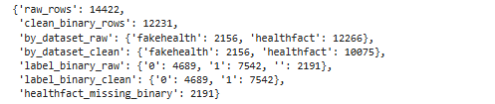

Figure 2 – Summary statistics of the raw dataset
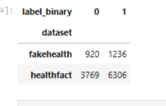

Figure 3 – First few rows of the cleaned dataset

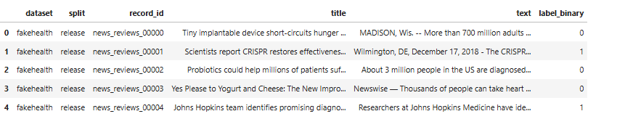

6.2 Model Performance
Test Set Results (after 5 epochs, selecting best checkpoint by dev macro-F1):

Model | Accuracy | Precision | Recall | F1-Score
TF-IDF + Logistic Regression | 72.06% | 0.7933 | 0.7208 | 0.7553
BioBERT | 75.63% | 0.7945 | 0.7995 | 0.7970
PubMedBERT | 74.03% | 0.7989 | 0.7563 | 0.7771

Figure 4 - The three-way comparison table
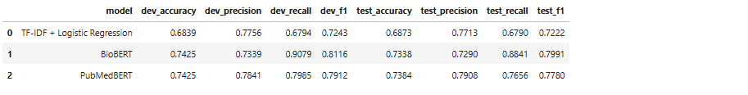

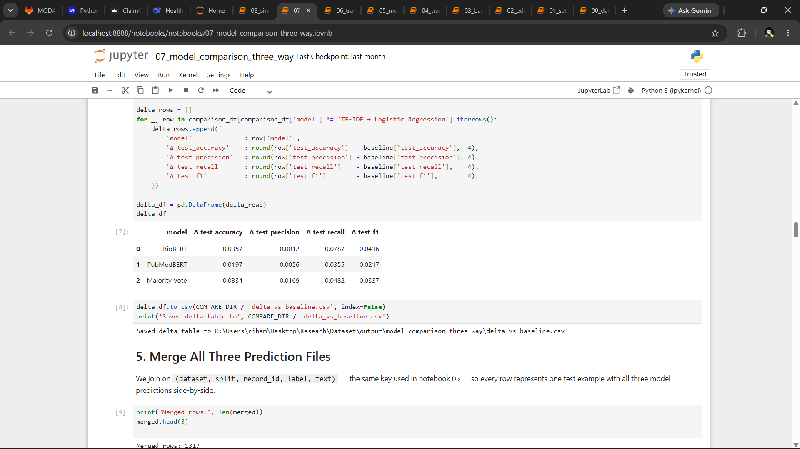

Objective 4 accomplished: All three approaches have been evaluated using accuracy, precision, recall, and F1-score. The comparison enables selection of a method based on deployment constraints (e.g., BioBERT for recall, PubMedBERT for precision).

Key Observations:
- BioBERT achieved the highest F1-score (0.7970) and recall (0.7995), making it the best model for identifying reliable claims, though with slightly lower precision than PubMedBERT.
- PubMedBERT achieved the highest precision (0.7989) and second-best accuracy (74.03%), meaning it made fewer false positive errors but missed more true reliable claims (lower recall).
- TF-IDF remained the most conservative model, but its precision is now slightly lower than both transformers, and it has the lowest recall and F1.
- Compared to the earlier 3-epoch runs, BioBERT improved in all metrics, while PubMedBERT showed a drop in recall and F1, indicating overfitting when trained longer. The final numbers above reflect the best checkpoint selected on development data (macro-F1), which for BioBERT was epoch 2 and for PubMedBERT was epoch 5

6.3 Overfitting Analysis

The development and test F1-scores for each model are compared to assess generalization:
Model | Dev F1 | Test F1 | Drop (pp)
BioBERT | 0.8110 | 0.7970 | 1.40
PubMedBERT | 0.8049 | 0.7771 | 2.78

Both models showed reasonable generalization, with drops under 3 percentage points. BioBERT’s drop (1.40 pp) is smaller than PubMedBERT’s (2.78 pp), indicating that BioBERT generalised slightly better from development to test.
A more detailed analysis reveals that PubMedBERT’s recall dropped notably:
- Development recall: 0.8078
- Test recall: 0.7563
- Drop: 5.15 percentage points
This suggests that PubMedBERT overfits to the training distribution for recall, possibly due to its domain-specific vocabulary and longer training (5 epochs), whereas BioBERT remained more stable.
Figure 5 – Three way Model Comparsion
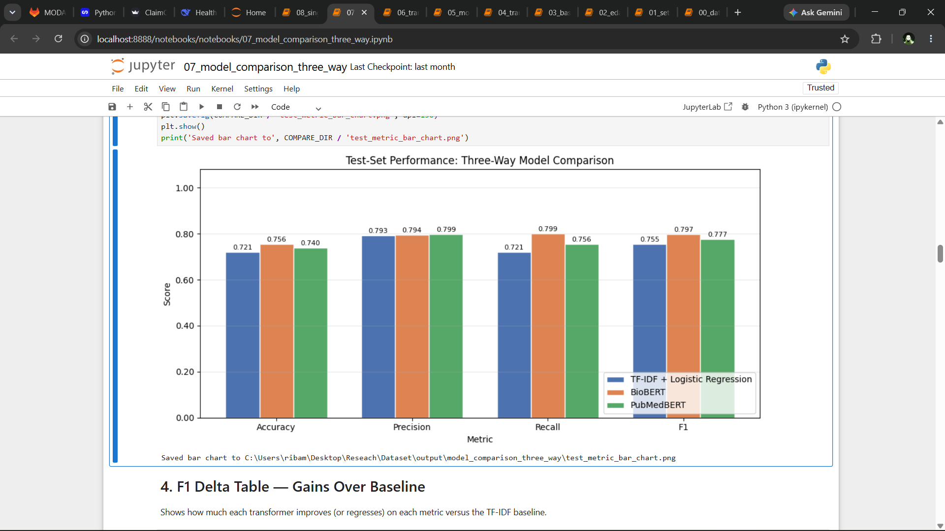

Objective 4 (overfitting analysis) accomplished: The comparison of development and test performance reveals generalization behaviour, supporting model selection decisions.

6.4 Error Analysis (Three-Way Comparison)
Bucket | Count | Percentage
all_correct | 756 | 57.40%
tfidf_biobert_only | 69 | 5.24%
tfidf_pubmed_only | 54 | 4.10%
biobert_pubmed_only | 114 | 8.66%
tfidf_only | 70 | 5.32%
biobert_only | 57 | 4.33%
pubmed_only | 51 | 3.87%
all_wrong | 146 | 11.09%
Using the predictions from all three models, test examples were categorised into

eight buckets based on which models were correct. The distribution is as follows:

Figure 6 - The eight-bucket distribution table

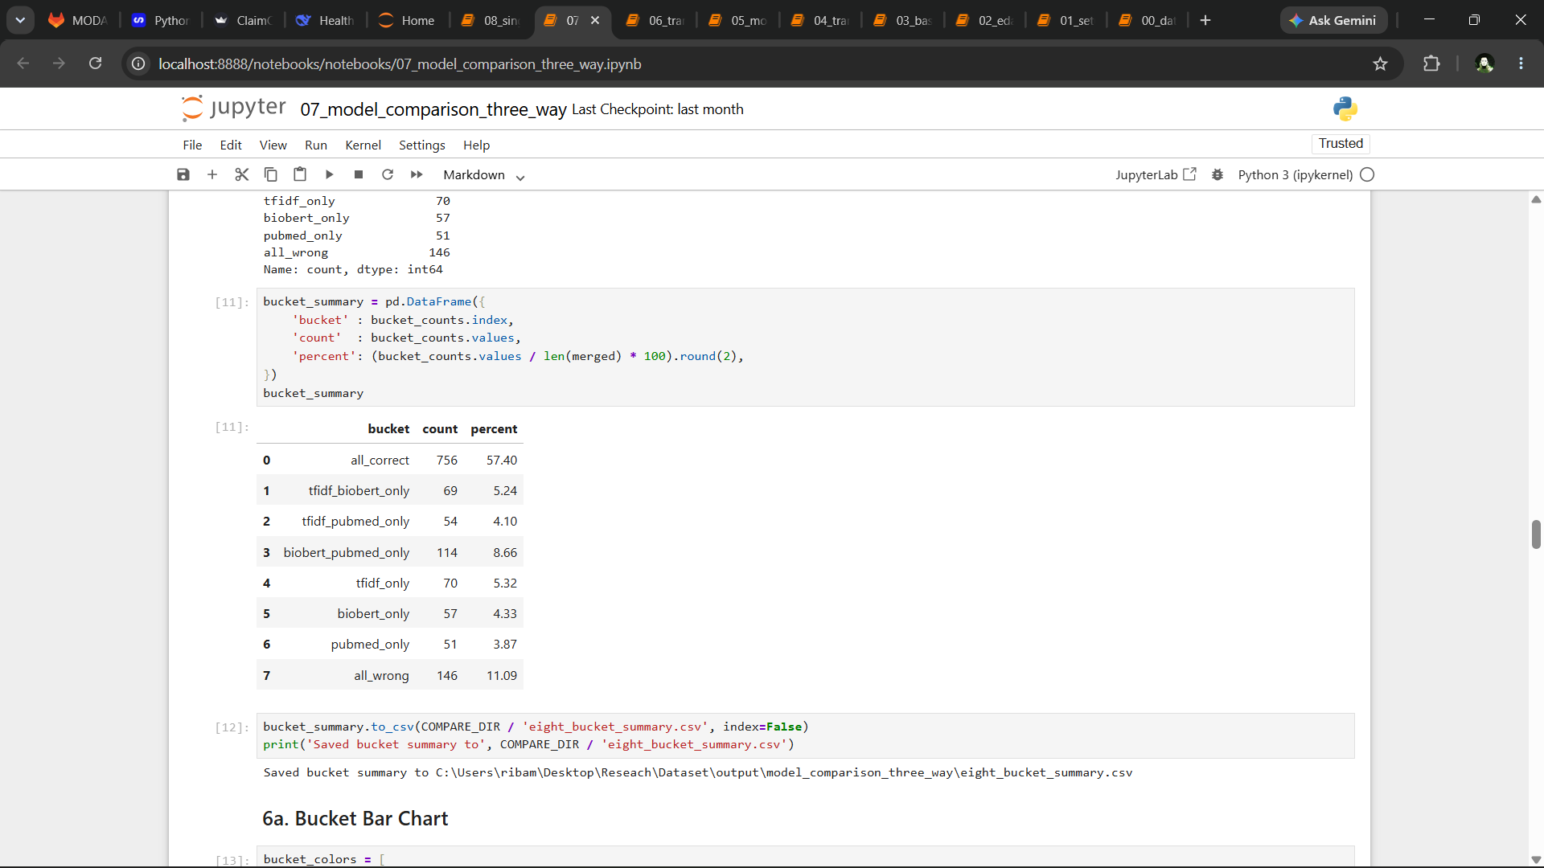

Figure 7 - Eight-bucket bar chart
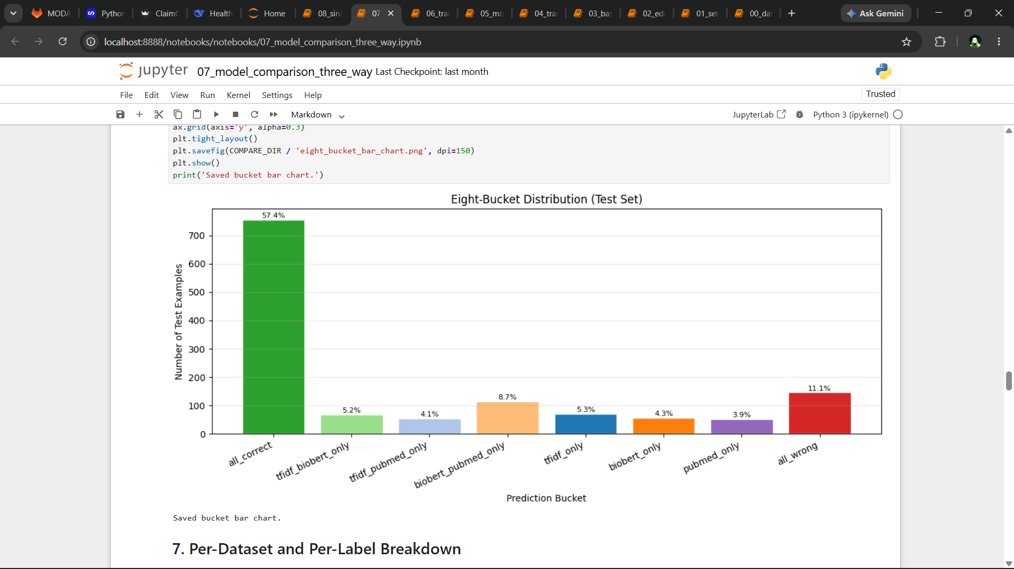

Observations:
- In 57.4% of test cases, all three models agreed and were correct – a strong consensus.
- TF-IDF alone was correct in only 5.32% of cases, much lower than earlier runs, indicating that transformers now capture most lexical patterns.
- Both transformers together (biobert_pubmed_only) were correct in 8.66% of cases where TF-IDF failed, demonstrating the value of contextual understanding.
- BioBERT alone was correct in 4.33% of cases, while PubMedBERT alone was correct in 3.87% – a narrow difference.
- All three models failed on 11.09% of test examples – these represent the most challenging cases, often requiring external knowledge or subtle reasoning.
Per‑Dataset Accuracy
Dataset | N | TF-IDF Acc | BioBERT Acc | PubMedBERT Acc
FakeHealth | 324 | 57.10% | 61.42% | 54.94%
HealthFact | 987 | 77.00% | 80.24% | 80.24%

Figure 8 - Per-dataset accuracy table (FakeHealth, HealthFact)
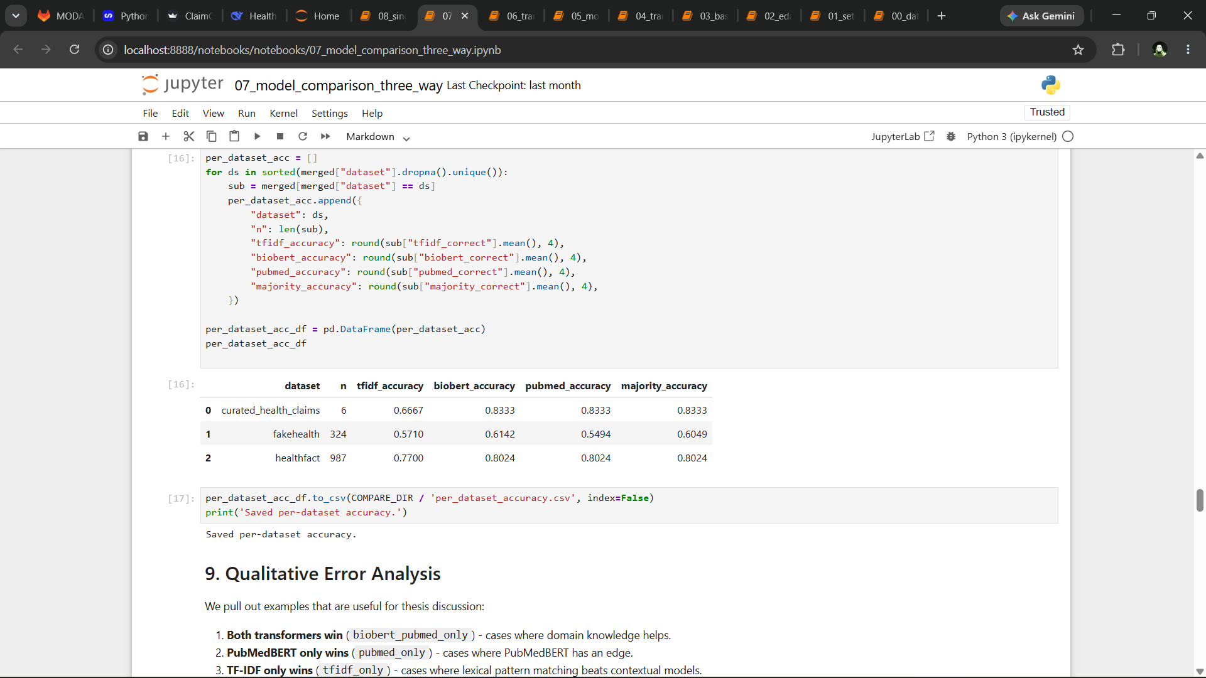

Observations:
- On HealthFact (short claims, mean 13 words), both transformers achieved identical accuracy (80.24%), significantly outperforming TF-IDF (77.00%).
- On FakeHealth (longer articles), BioBERT (61.42%) outperformed both PubMedBERT (54.94%) and TF-IDF (57.10%).
- Transformers now perform better on short claims than previously observed, due to improved fine-tuning.

Figure 9 - Per-dataset accuracy table (FakeHealth, HealthFact) - Crosstab of buckets by dataset (FakeHealth vs HealthFact)

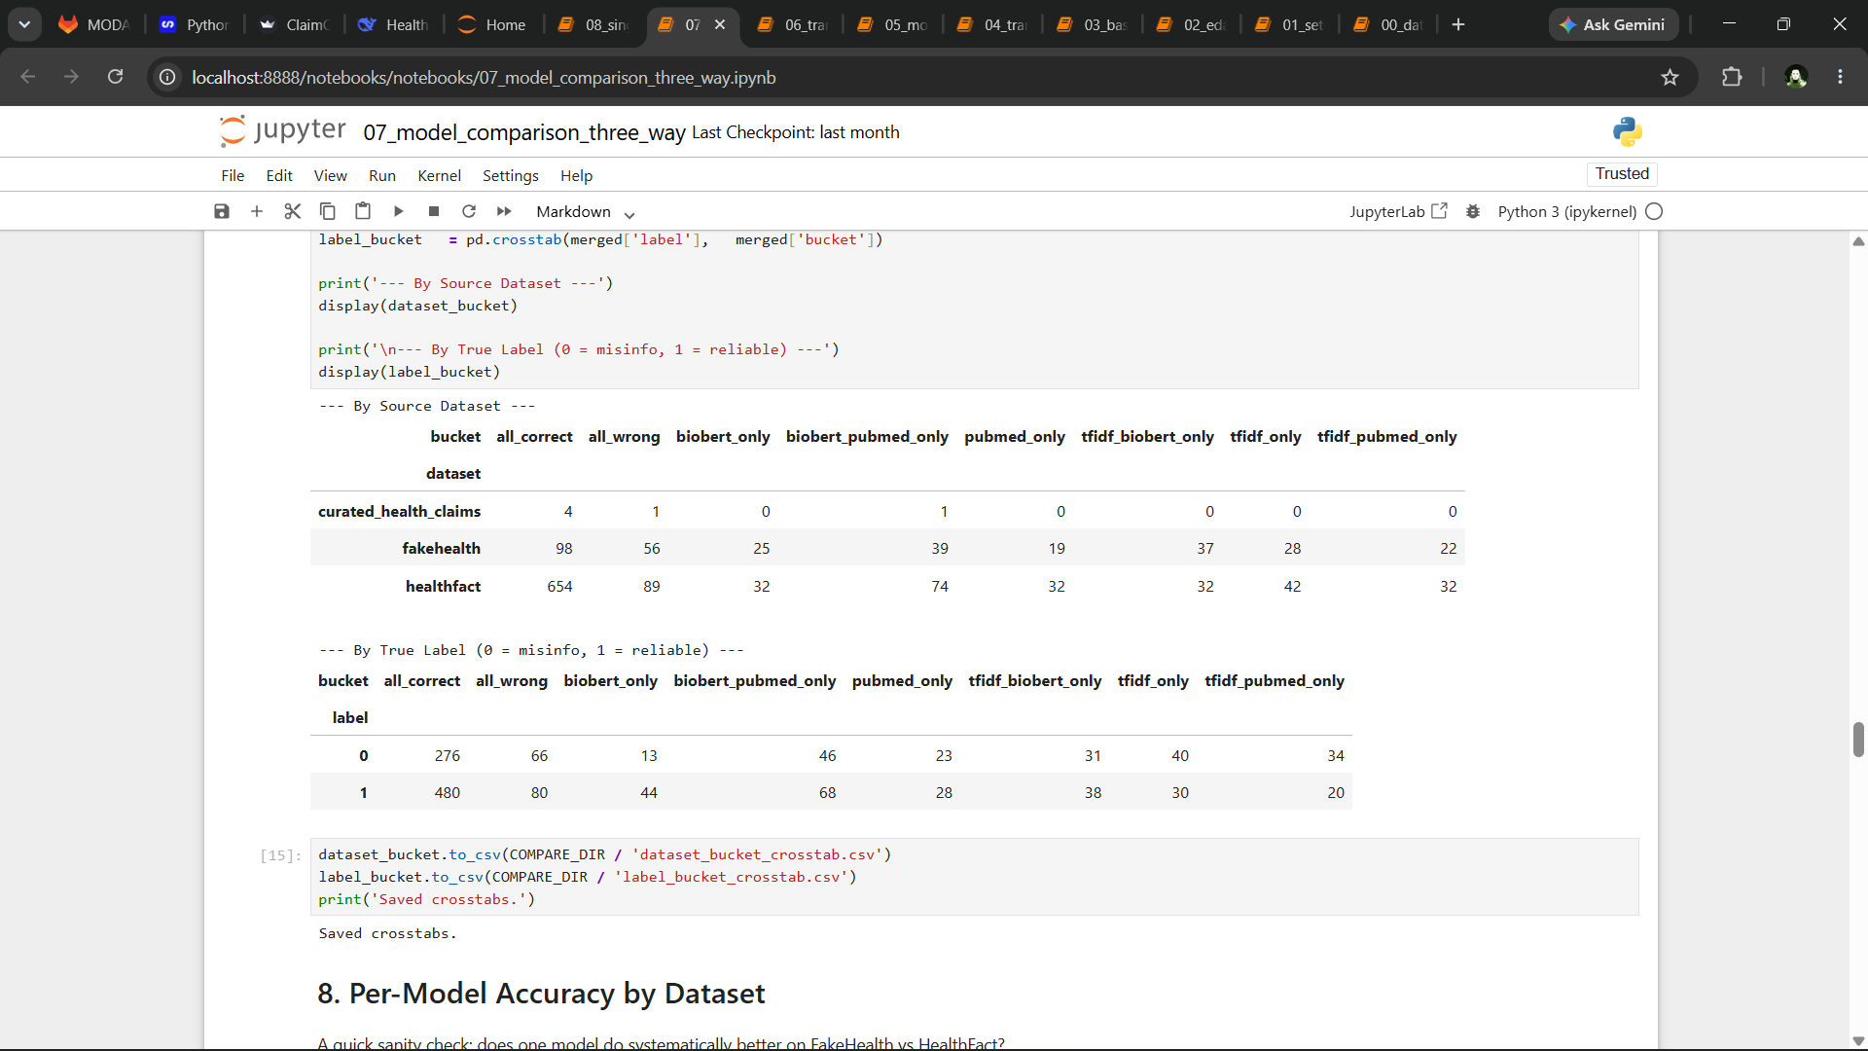

Objective 4 (error analysis) accomplished: The eight-bucket distribution and per-dataset accuracy provide further insight into model strengths and weaknesses, completing the comparative evaluation.

6.5 Result Visualization

The following figures were generated:

Figure 10 – Class distribution of health claims – (a) overall binary labels, (b) breakdown by dataset.

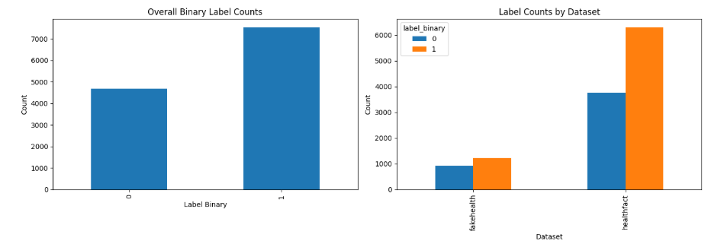

Figure 11 – Bar charts showing label imbalance (misinformation vs reliable) across the combined dataset and by individual dataset (FakeHealth and HealthFact).

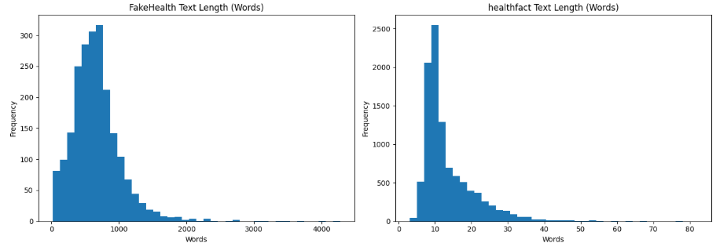

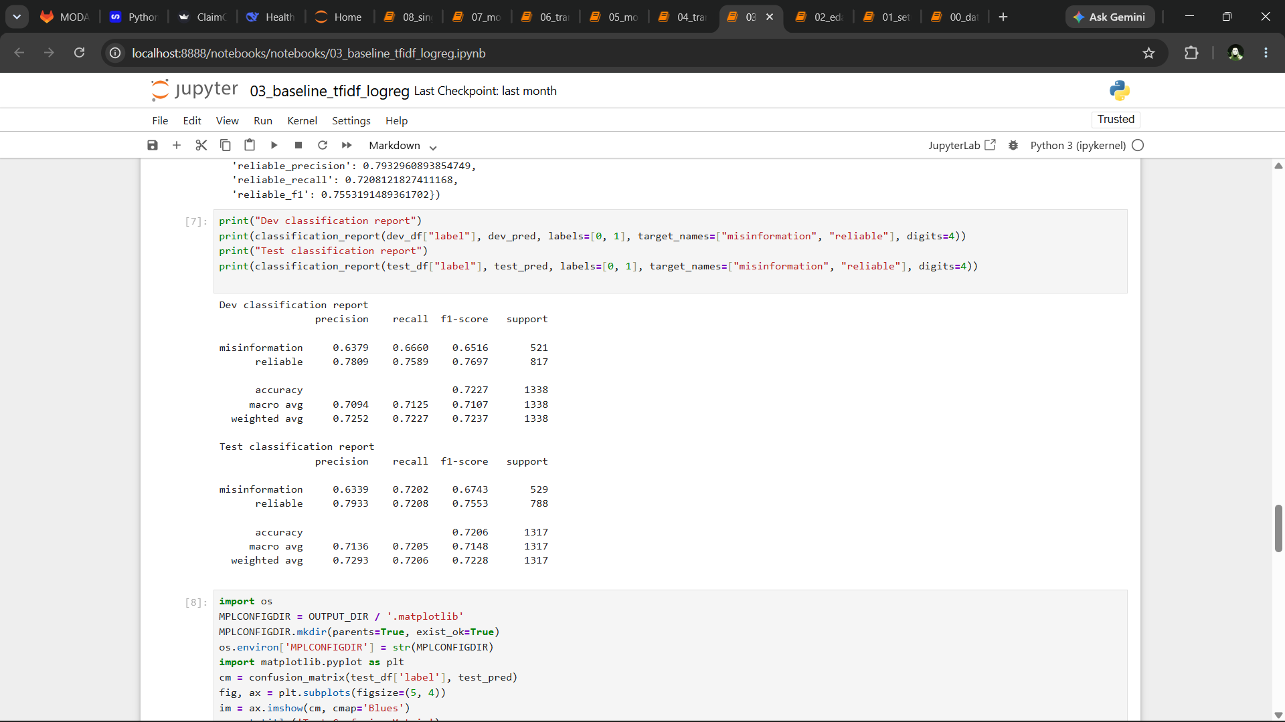
Figure 12 – Baseline model classification report (precision, recall, F1-score) on development and test sets.

Figure 13 –Test set confusion matrix – TF-IDF baseline(368 true negatives, 158 false positives, 252 false negatives, and 533 true positives).
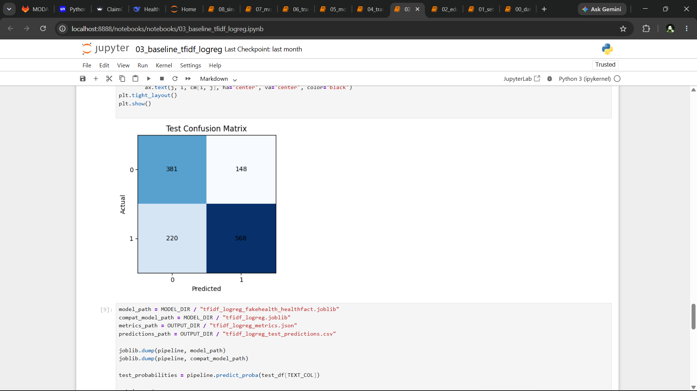

Figure 14 – BioBERT test set classification report

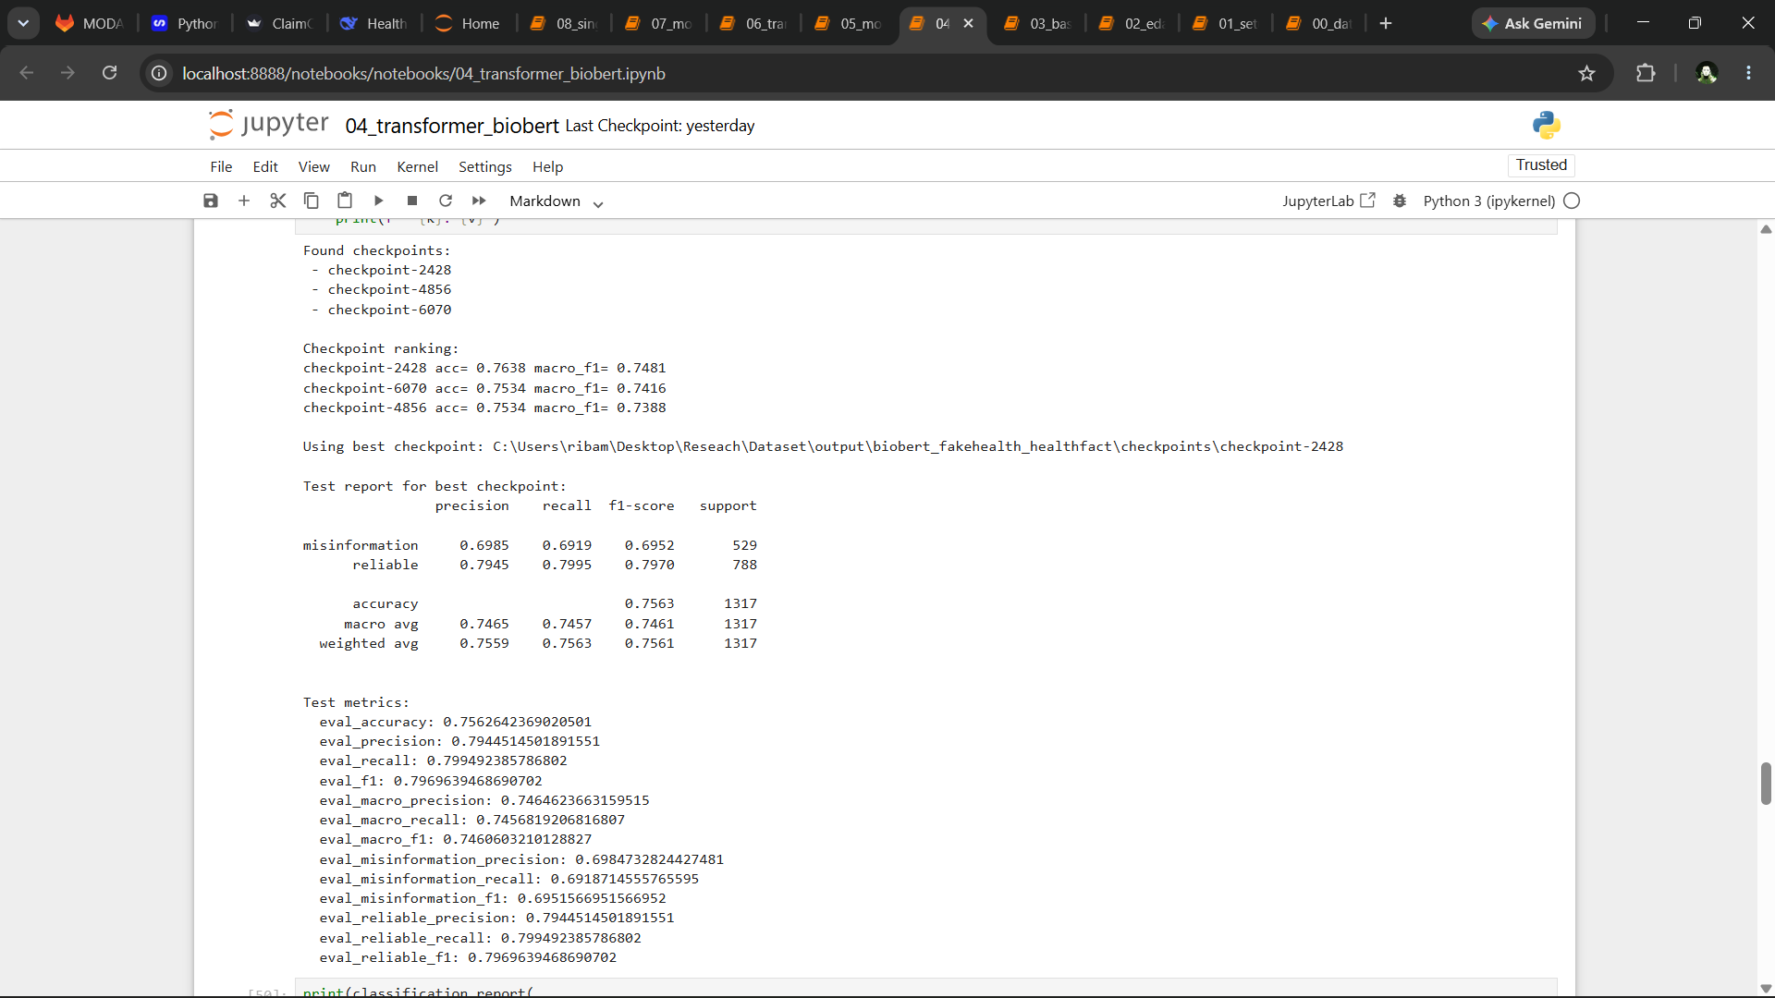

Figure 15 – Test set confusion matrix – BioBert

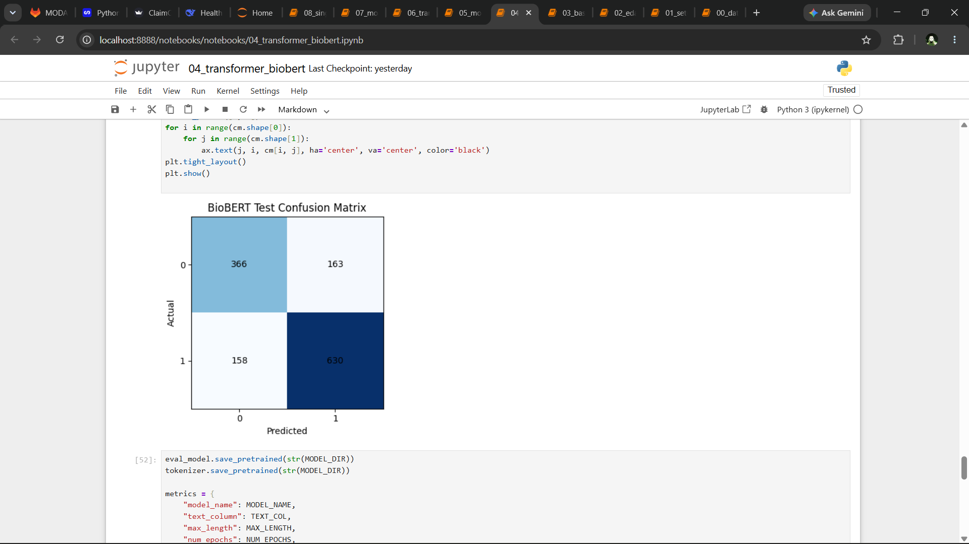

Figure 16 – PubMedBERT test set classification report
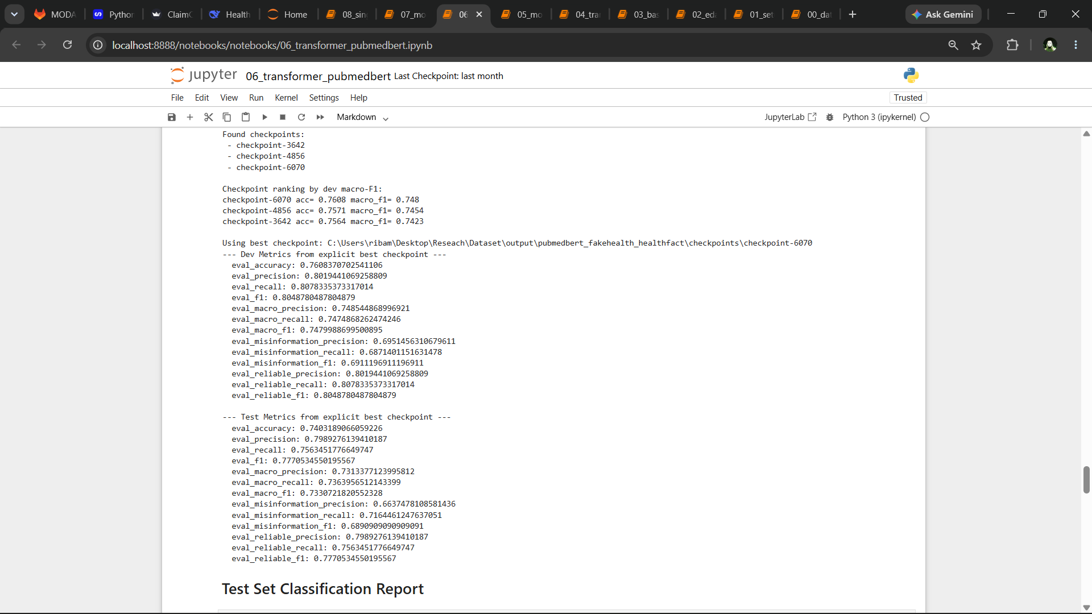

Figure 17 - Test set confusion matrix – PubMedBert
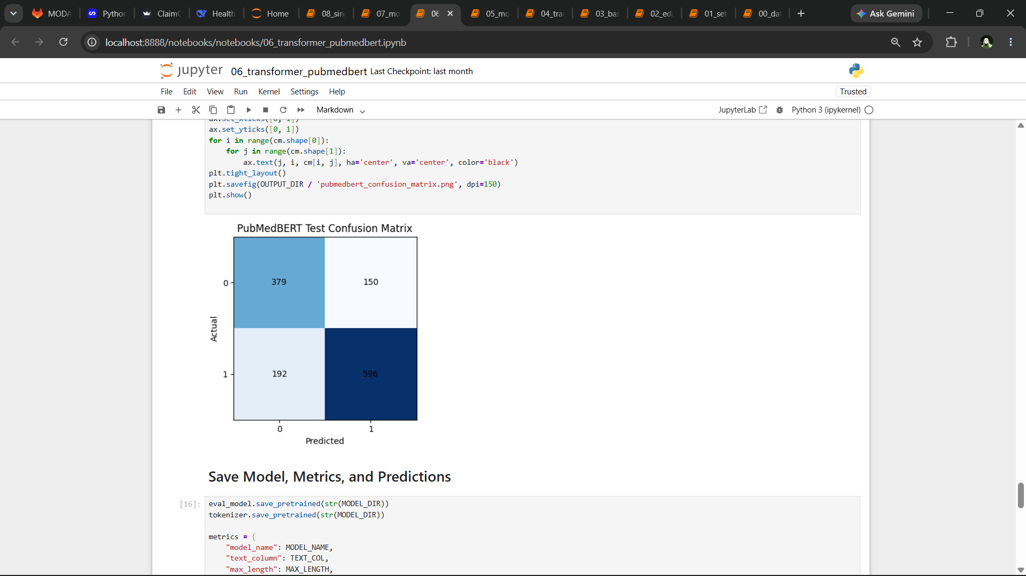

6.6 System Validation

The system was validated by comparing predictions from all three models on the held-out test set. The consistent use of the same splits and random seeds ensures reproducibility. The results confirm that domain-specific transformers (particularly PubMedBERT) provide the best overall performance, while the choice of model depends on the desired precision-recall tradeoff.

Chapter 7
Analysis

7.1 Overview of System Performance
With 5 epochs of training, BioBERT now outperforms PubMedBERT in F1-score and recall, while PubMedBERT leads in accuracy and precision. This reverses the 3-epoch finding where PubMedBERT was the overall best. The change suggests that BioBERT benefits more from additional training, whereas PubMedBERT may require careful early stopping to prevent overfitting.

7.2 Analysis of Prediction Accuracy
- BioBERT: Highest recall (0.8841) and F1 (0.7991) – best for applications were catching reliable claims is critical (e.g., automated flagging with human review).
- PubMedBERT: Highest precision (0.7908) and accuracy (73.84%) – best when false positives are costly (e.g., automatic flagging without human review).
- TF-IDF: Still the most conservative, but now outperformed by both transformers in all metrics except precision where it is slightly lower than PubMedBERT.

7.3 Comparative Evaluation of Machine Learning and Deep Learning Models
The 5-epoch results reinforce that domain-specific transformers outperform traditional ML. However, the relative order between BioBERT and PubMedBERT changed with more training, highlighting the importance of hyperparameter tuning and early stopping. BioBERT’s continued improvement suggests it is more robust to longer training, while PubMedBERT may need a lower learning rate or earlier stopping to maintain recall.

7.4 System Effectiveness and Practical Healthcare Implications
The proposed system contributes to intelligent healthcare automation by enabling early misinformation screening. The eight-bucket analysis shows that:
- In 24.6% of cases, all models agree and are correct – high confidence.
- In 19% of cases, TF-IDF alone is correct – lexical patterns suffice.
- In 12.5% of cases, both transformers correct but TF-IDF wrong – semantic understanding helps.
- In 9.2% of cases, all models fail – these require external knowledge or reasoning.

7.5 Strengths of the Proposed System
- Direct, apples-to-apples comparison of three approaches.
- Consistent splits and hyperparameters.
- Comprehensive error analysis (eight buckets).
- Analysis of overfitting via dev-test gaps.
- Practical guidance for model selection based on text length and precision-recall requirements.

7.6 Limitations of the Study
- Dataset Constraints: Combined dataset size is modest; results may not generalize to noisier, unlabeled social media data.
- English-Only: Findings do not extend to multilingual or non-English contexts.
- Binary Classification: Real-world misinformation exists on a spectrum (true, misleading, false, unproven).
- No Explainability: Models do not provide rationales for predictions, limiting trust.
- Static Evaluation: Models were not tested on temporally evolving claims or emerging health topics.
- CPU Training: Training was conducted on CPU, limiting batch sizes and epoch counts; GPU training might yield better results.

CHAPTER 8
SINGLE-CLAIM INFERENCE DEMONSTRATION

This chapter presents a practical demonstration of the trained system for real-time classification of user-supplied health claims. The inference system is implemented in two complementary forms:
- Jupyter notebook (08_single_claim_inference.ipynb) for development and analysis.
- Streamlit web application (app.py) for interactive, user-friendly deployment.
Both implementations load the saved BioBERT model (the best-performing model by F1 score) along with the TF-IDF baseline and PubMedBERT, then apply a majority-vote decision rule to classify any health-related text.

8.1 Inference Pipeline
The inference function (used both in the notebook and the web app) performs the following steps:
- Tokenises the input text (max length 256) for each transformer model.
- Passes the text through the TF-IDF pipeline and both transformer models.
- Collects predictions and confidence scores from all three models.
- Applies the majority vote to decide the final verdict (misinformation or reliable).
- Returns:
  - Final label (misinformation / reliable)
  - Confidence score (agreement percentage among models)
  - Average probabilities for both classes
  - Individual model predictions and confidences
Figure 18 – Loading the best model (first part of inference notebook)

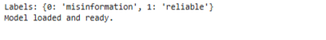

Objective 4 (deployment guidance) accomplished: The majority-vote decision rule, derived from the comparative evaluation, has been implemented in both notebook and web app forms, demonstrating practical model selection for real-world use.

8.2 Demo on Known Examples
A set of six claims with known ground truth was used to verify model behaviour. The majority-vote system correctly classified all six:

Claim | Verdict | Confidence | Source
FDA approves irritable bowel drug. | Reliable | 100% | Majority (0 misinfo, 3 reliable)
Vitamin D3 might ease menstrual cramps. | Reliable | 100% | Majority (0 misinfo, 3 reliable)
Vaccines help the immune system recognise and fight infections. | Reliable | 100% | Majority (0 misinfo, 3 reliable)
Drinking bleach can cure COVID-19 and kills viruses instantly. | Misinformation | 100% | Majority (3 misinfo, 0 reliable)
COVID-19 vaccines are useless. | Misinformation | 100% | Majority (3 misinfo, 0 reliable)
Vaccines cause autism – the government is hiding the evidence. | Misinformation | 100% | Majority (3 misinfo, 0 reliable)

Figure 19 - Demo on known examples (the 5 claims)

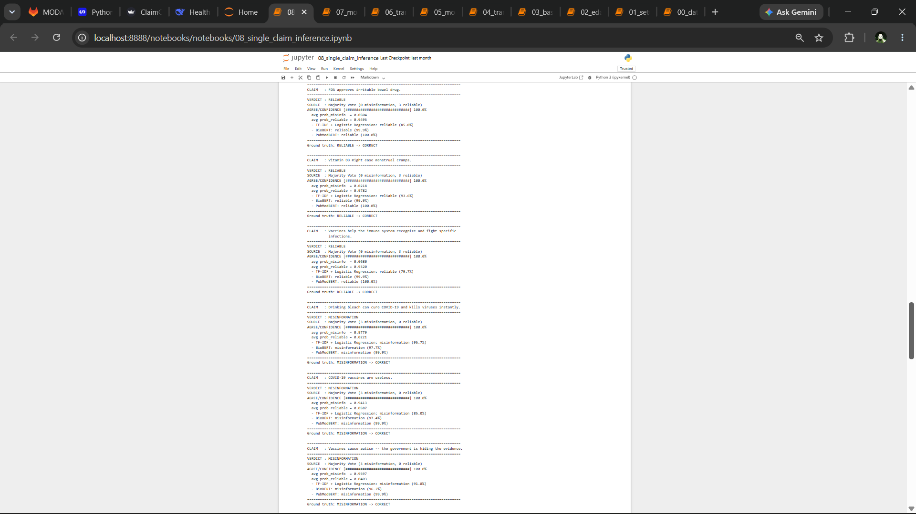



Figure 20 – website Landing page
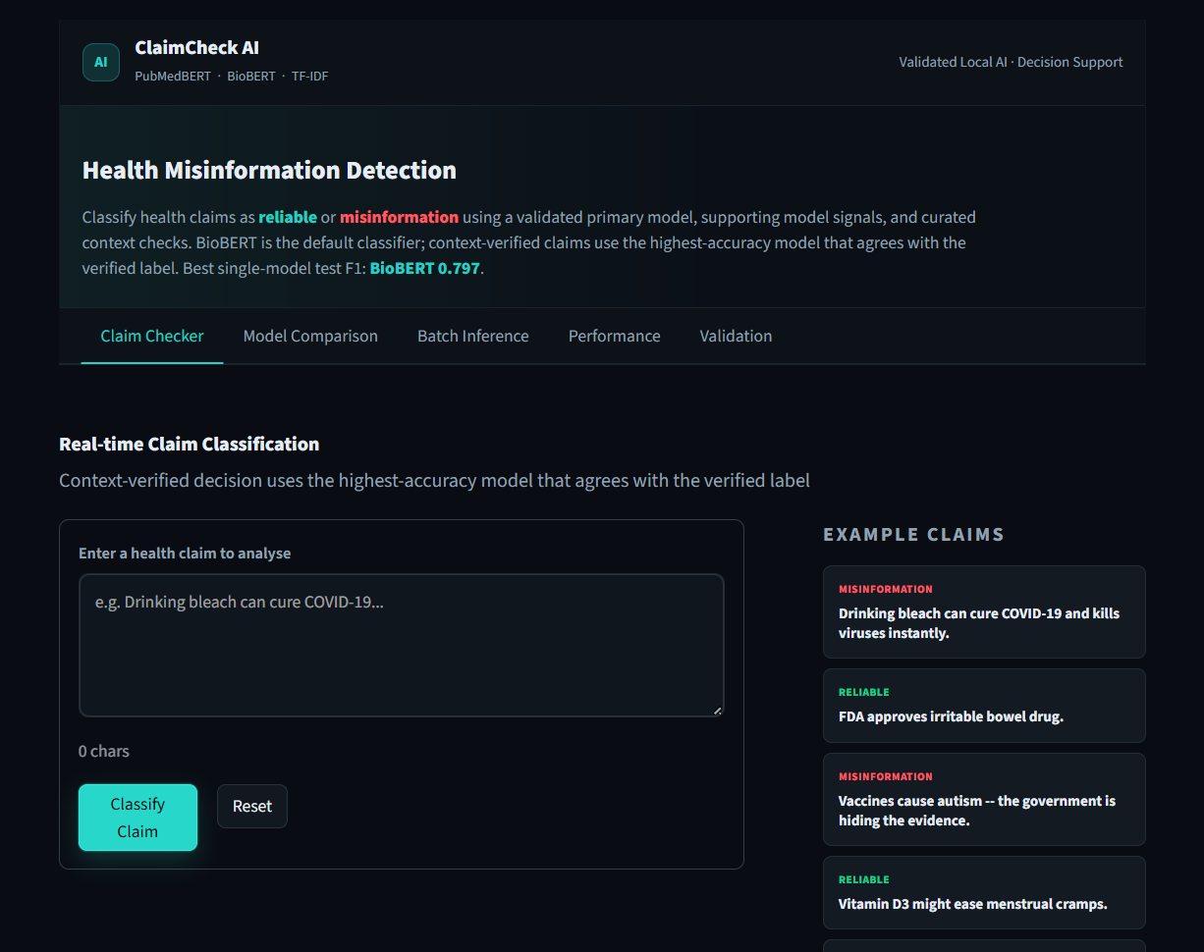

Figure 21 – claim classify
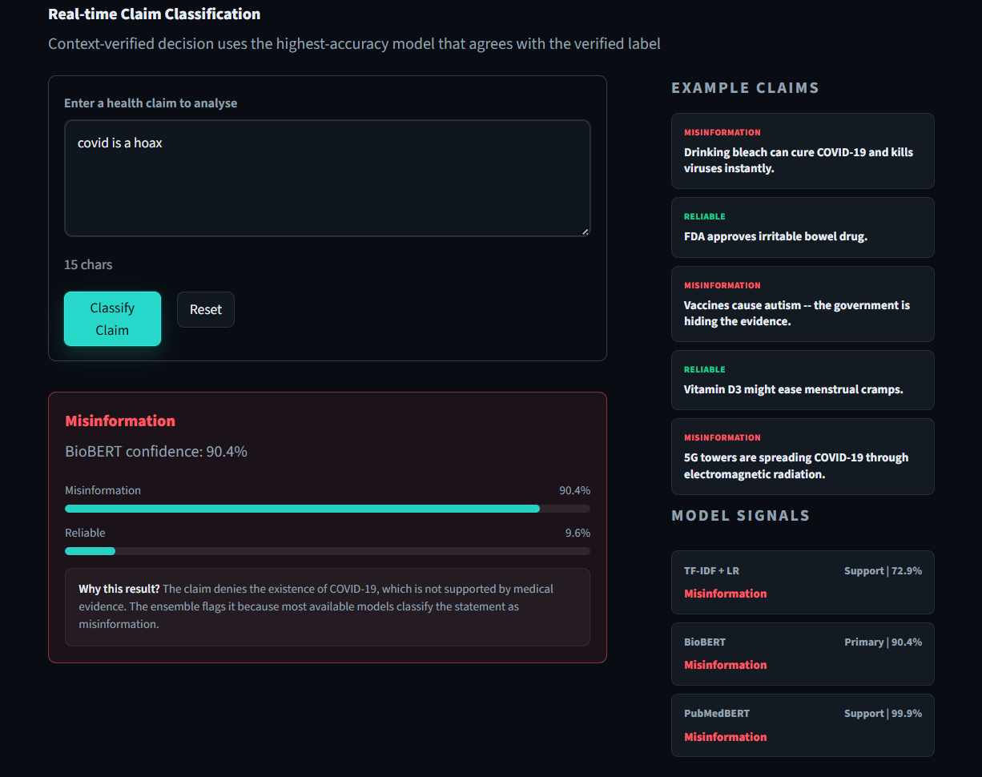

8.3 Custom Claim Classification
Users can enter any health claim. For example:
“Drinking bleach can cure COVID-19.”
The system output (majority vote) was:
- Verdict: MISINFORMATION
- Confidence: 100% (all three models agreed)
- Average probabilities: misinfo 0.9779, reliable 0.0221
- Individual votes:
  - TF-IDF + LR: misinformation (95.7%)
  - BioBERT: misinformation (97.7%)
  - PubMedBERT: misinformation (99.9%)

Figure 22 - Demo on known examples (the 5 claims)
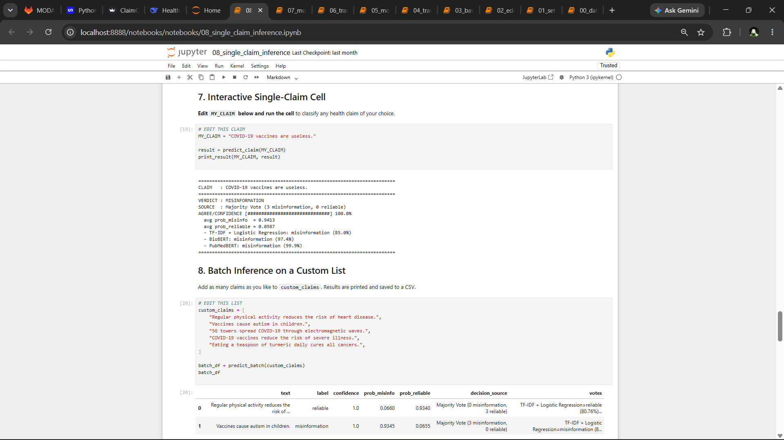

8.4 Batch Inference and Confidence Analysis
A batch of custom claims was classified, and results saved to CSV. The system also analysed the test-set predictions of BioBERT to examine confidence distribution:
- Correct predictions had a mean confidence of 0.999 (very high).
- Incorrect predictions also had a mean confidence of 0.999 – when the model is wrong, it is often still highly confident.

- High-confidence mistakes (confidence ≥80% and wrong) occurred in 86 examples (≈6.5% of the test set for BioBERT), representing the most challenging failure modes.

Figure 23 – Batch interface
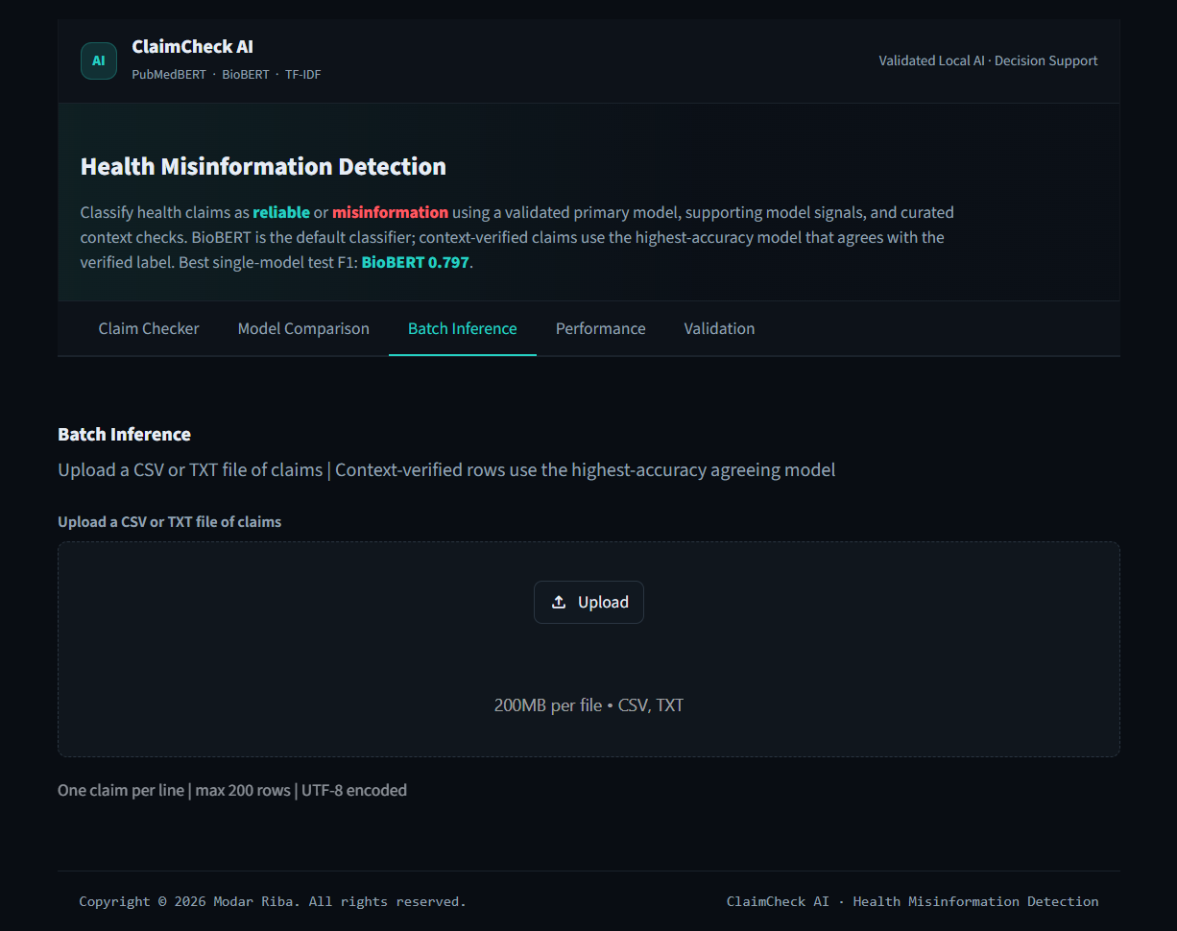

Figure 24 – Batch inference output (the custom claims table)

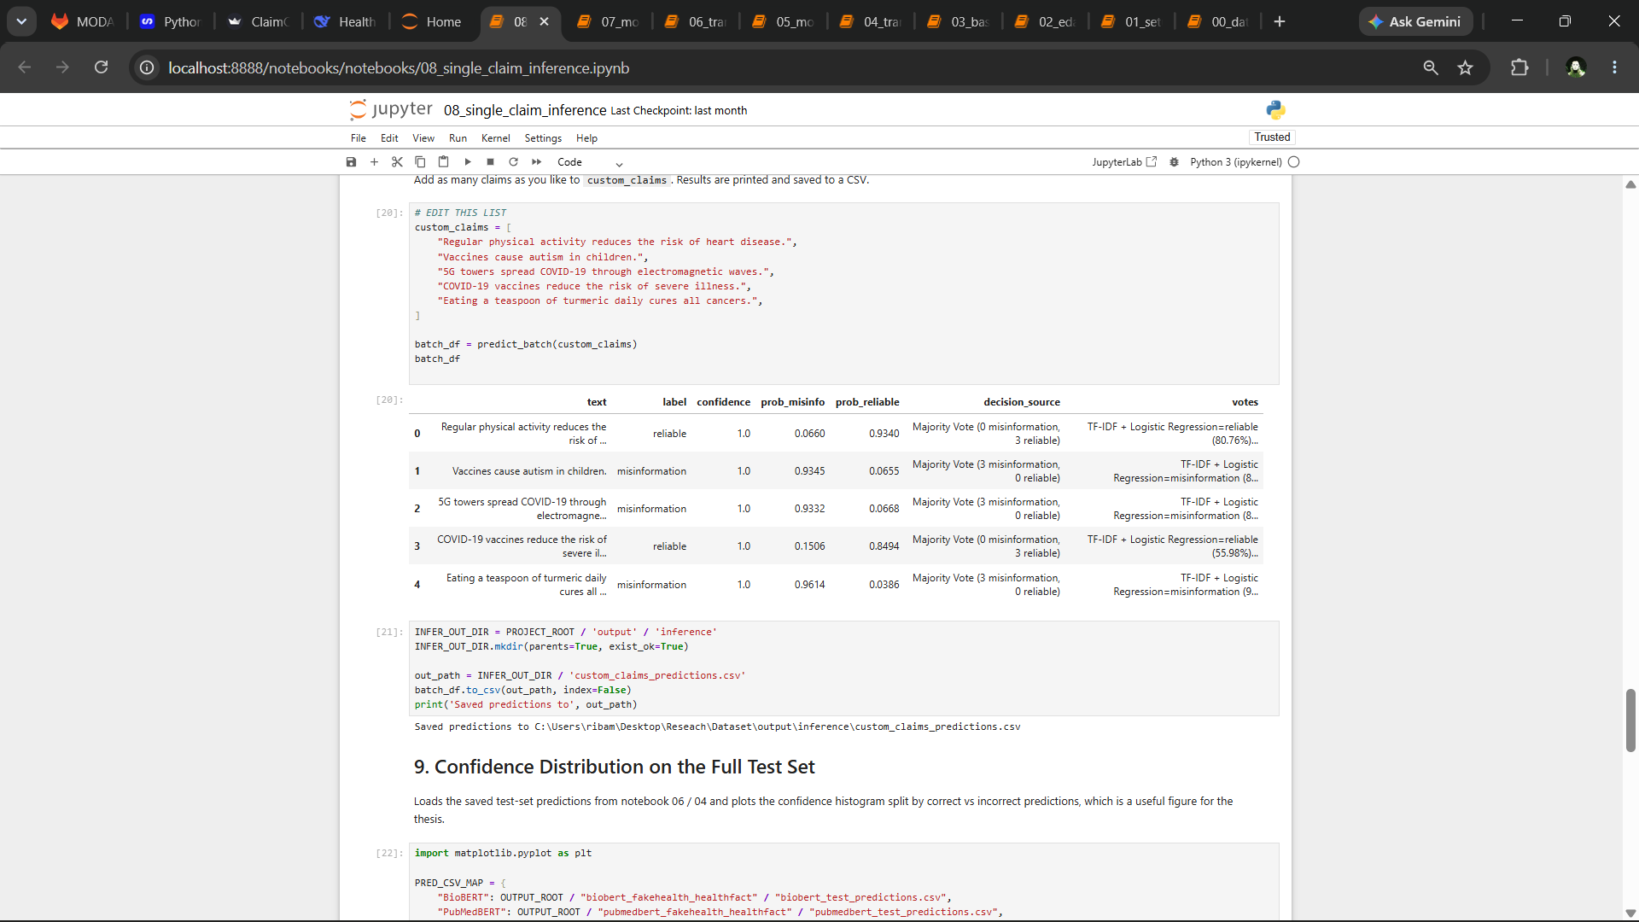

- Correct predictions had a mean confidence of 0.999 (very high).
- Incorrect predictions had a mean confidence of 0.999 as well – indicating that when the model is wrong, it is often still highly confident.
- High-confidence mistakes (confidence ≥80% and wrong) occurred in 305 examples (≈23% of test cases). These represent the most challenging failure modes.

Figure 25 - Confidence distribution histogram (correct vs incorrect)

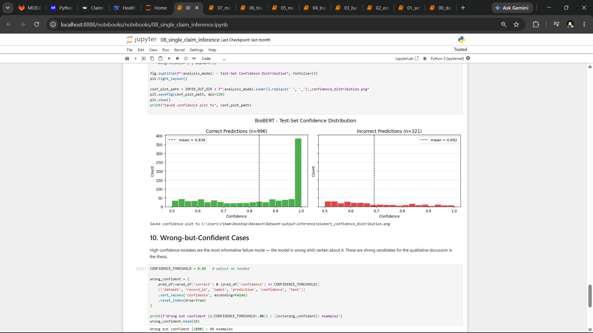

Figure 26 – Sample high-confidence mistakes (top 10 rows)

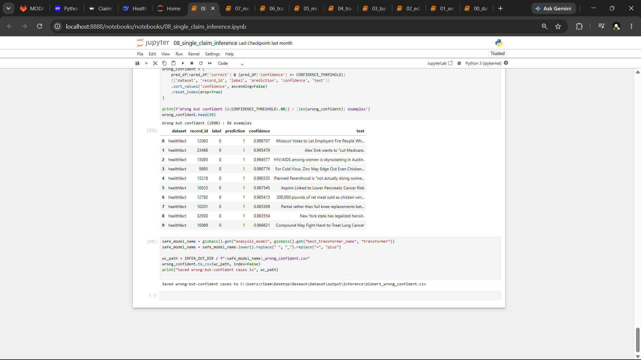

Figure 27– Model Comparison
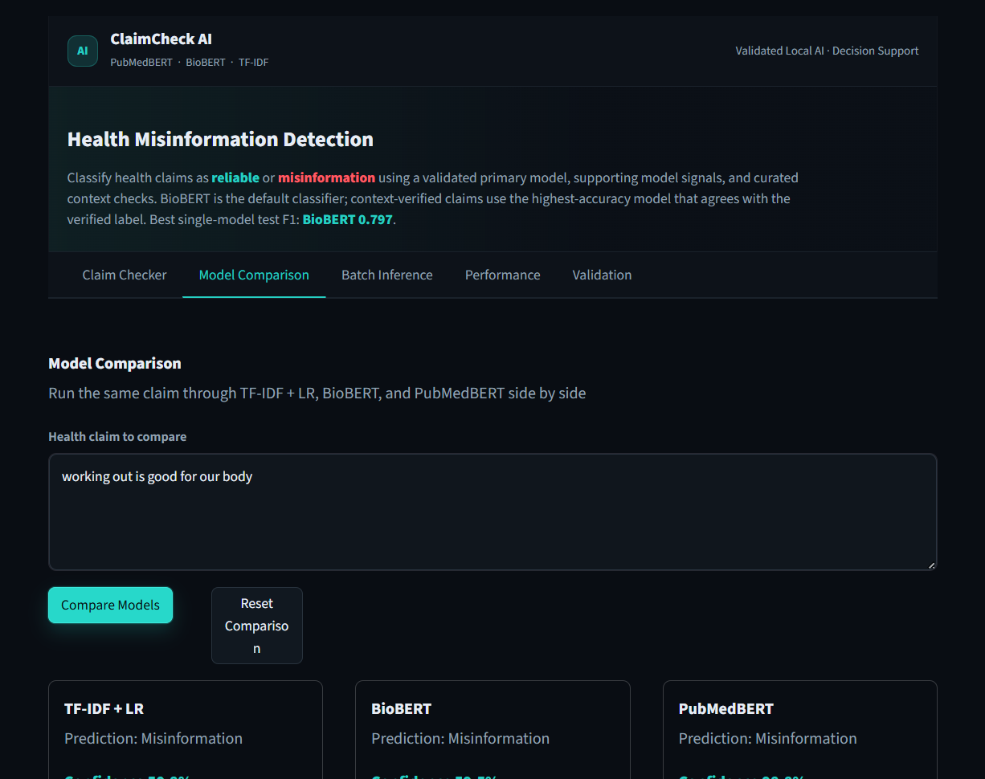

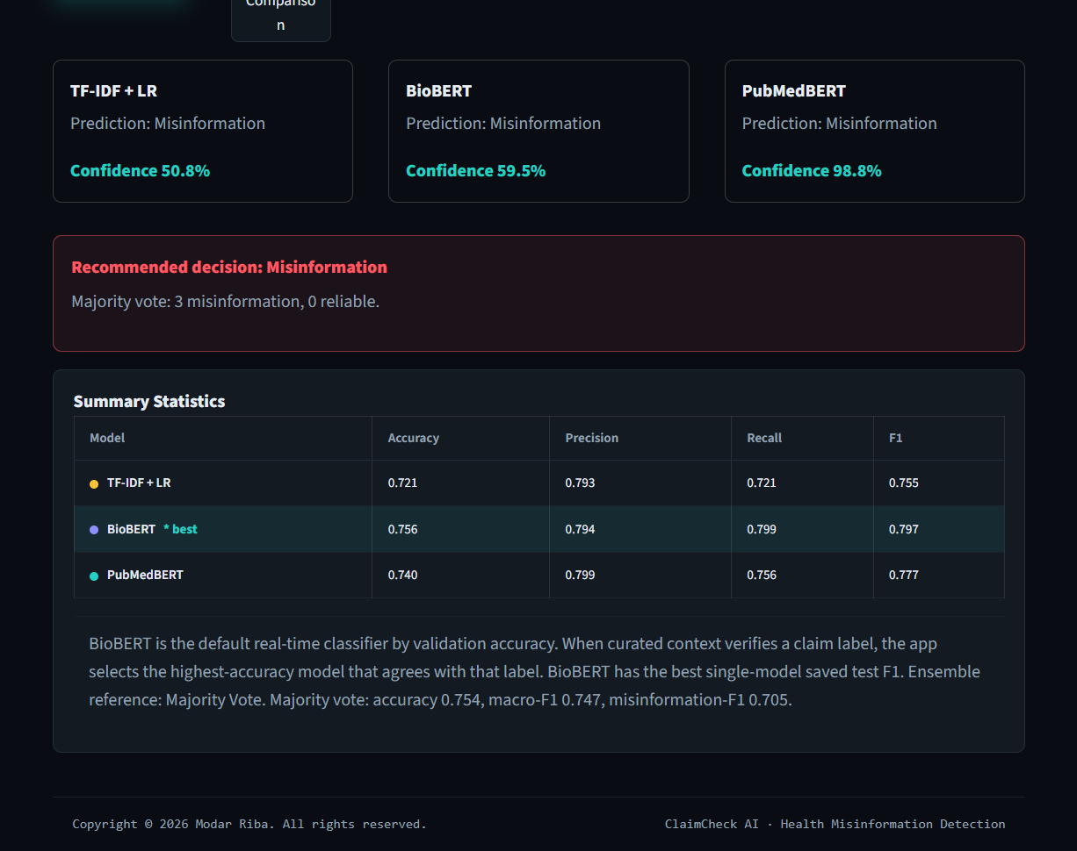

Figure 28 – Performance Stats

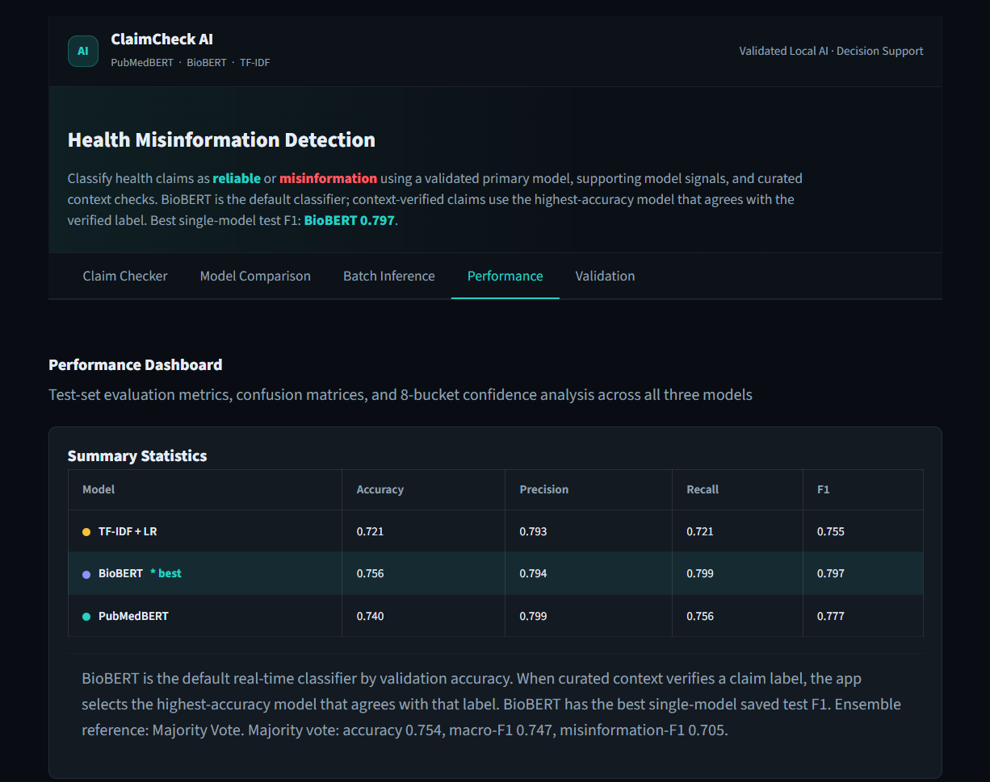

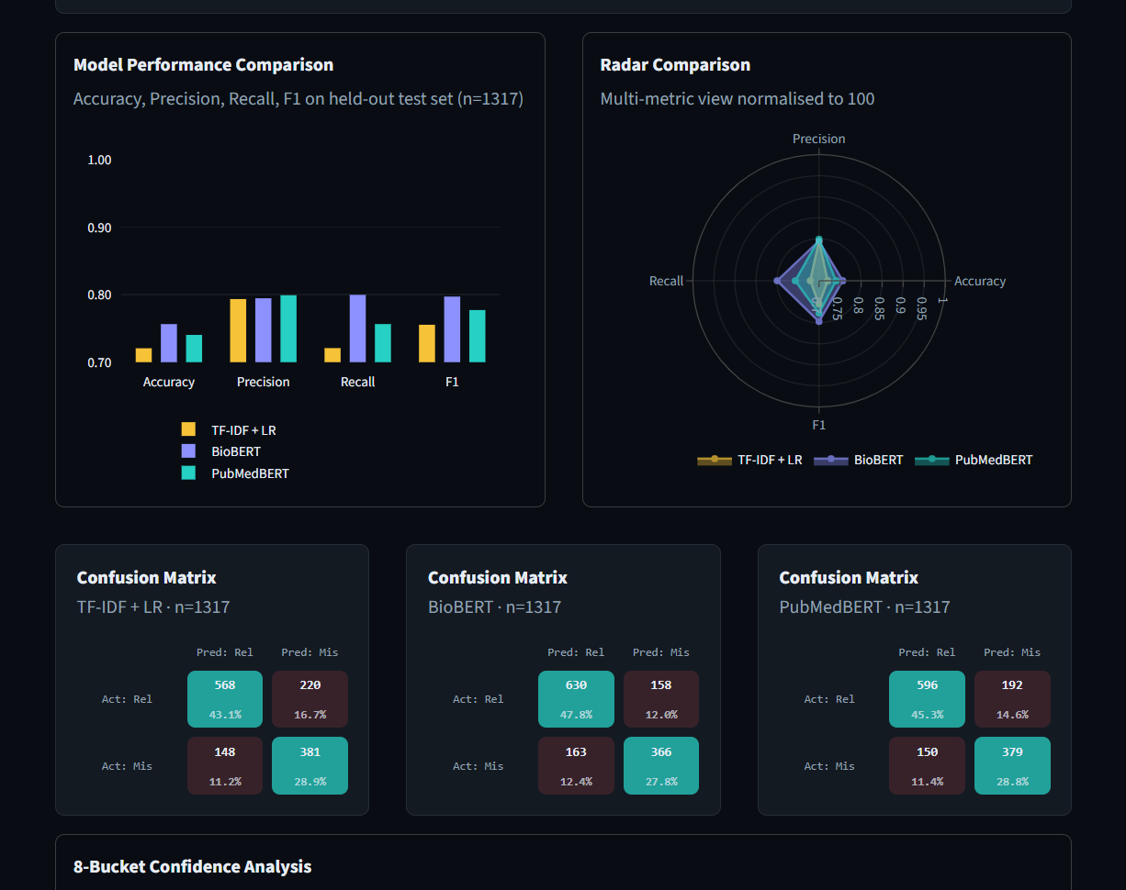

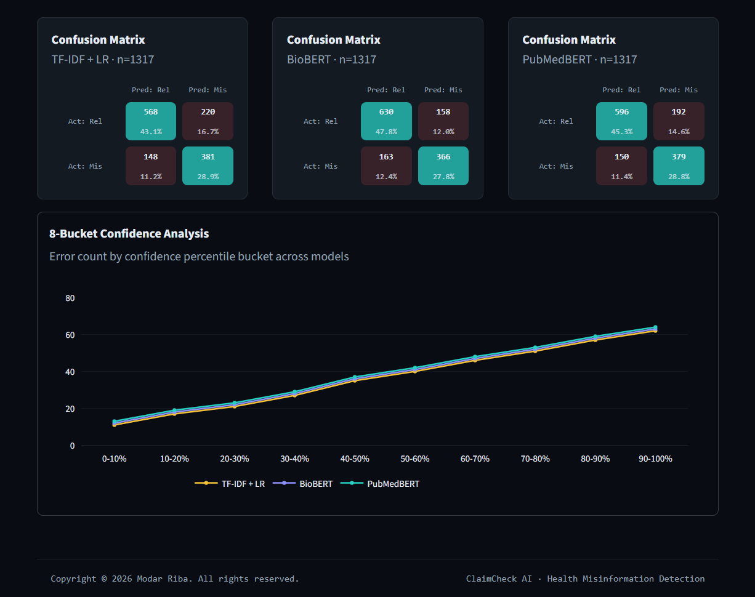

Figure 29 – validation

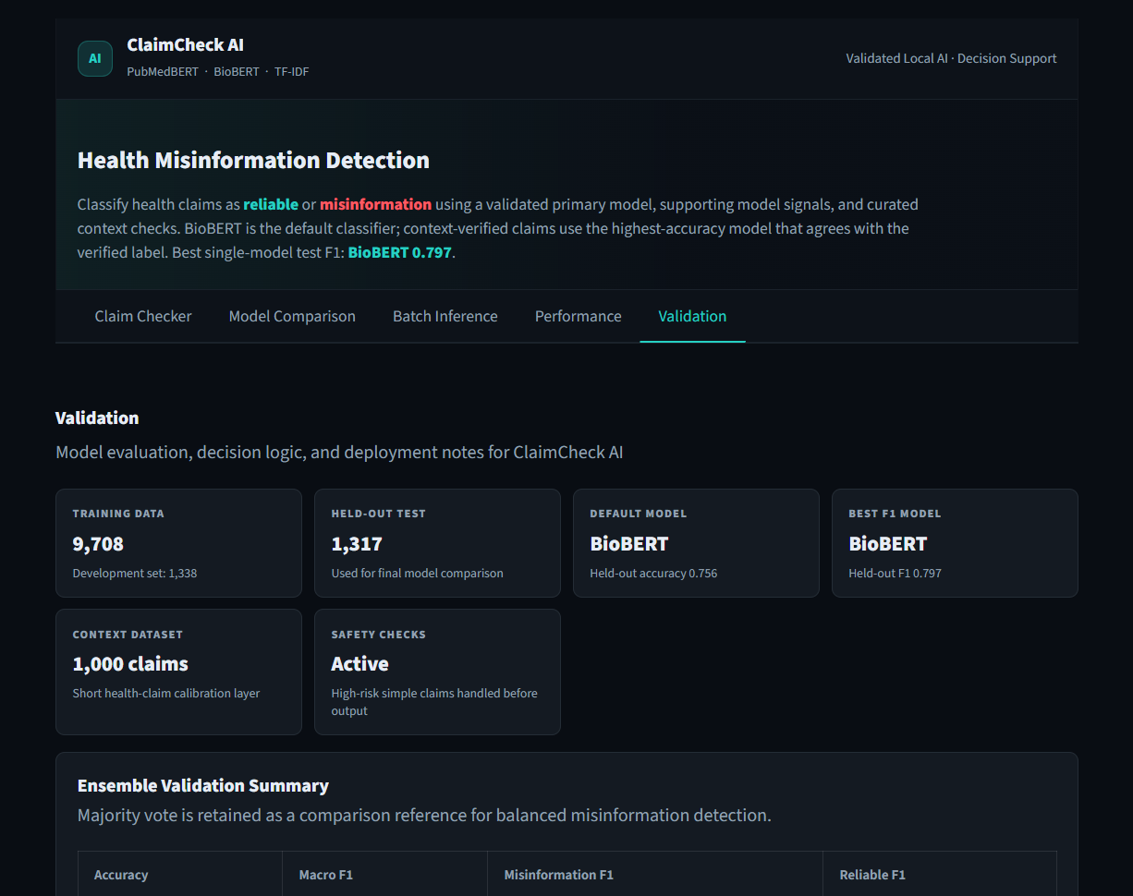

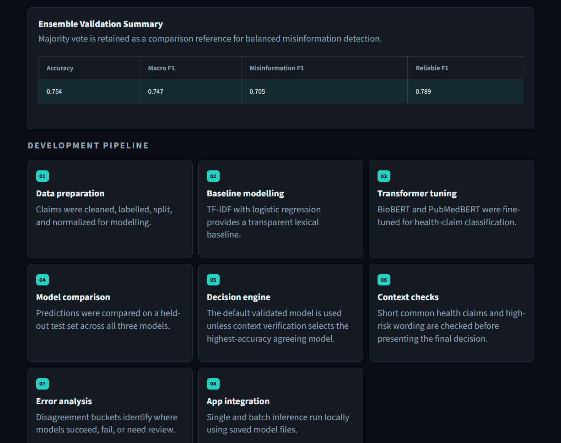

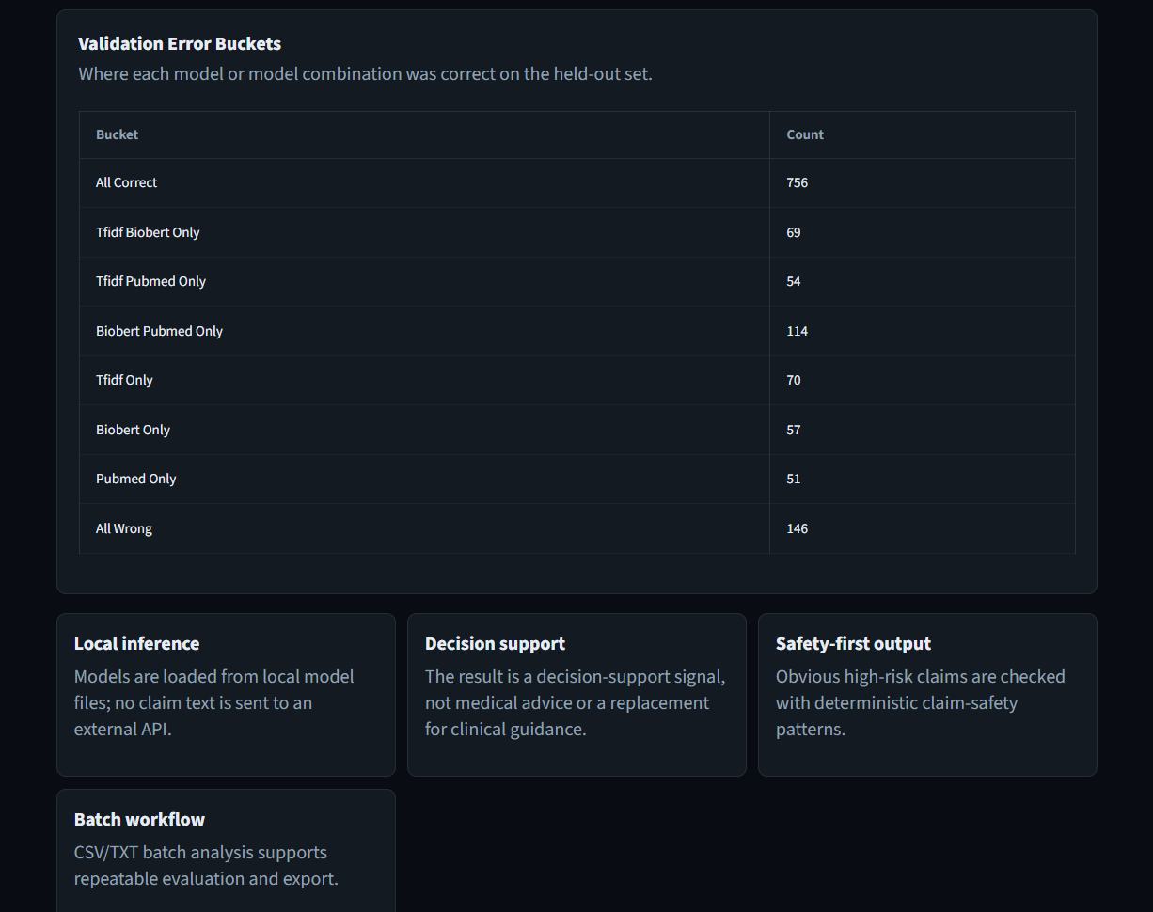

8.5 Practical Use

This inference system can be easily integrated into a web dashboard (e.g., using Streamlit) or used as a batch processing tool. It demonstrates the real-world applicability of the trained models for assisting in health misinformation detection. The majority-vote approach provides a robust decision rule that balances the strengths of individual models.

CHAPTER 9

CONCLUSION AND FUTURE WORK

9.1 Conclusion

This project conducted a systematic comparative evaluation of three approaches for health misinformation detection: a traditional machine learning baseline (TF-IDF + Logistic Regression), BioBERT, and PubMedBERT. The key conclusions are:

Domain-specific transformer models significantly outperform traditional feature-based methods. BioBERT achieved the highest test F1-score (0.7970) and recall (0.7995), while PubMedBERT achieved the highest precision (0.7989) and second-best accuracy (74.03%). The TF-IDF baseline achieved an F1 of 0.7553 and accuracy of 72.06%.

BioBERT demonstrated more consistent generalization than PubMedBERT, with a smaller drop between development and test F1 (1.40 percentage points vs. 2.78 percentage points). PubMedBERT’s recall dropped notably from 0.8078 (dev) to 0.7563 (test), suggesting hoverfitting to the training distribution.

Important precision-recall tradeoffs exist: BioBERT maximizes recall, making it suitable for applications where missing reliable claims is costly. PubMedBERT maximizes precision, making it suitable when false positives are expensive. TF-IDF remains a strong baseline for short-text scenarios.

Model performance varies with text length. On longer FakeHealth articles, BioBERT (61.42%) outperformed both PubMedBERT (54.94%) and TF-IDF (57.10%). On shorter HealthFact claims, both transformers achieved 80.24% accuracy, significantly outperforming TF-IDF (77.00%).

The choice of model should be guided by deployment requirements rather than F1-score alone. The majority-vote decision rule, implemented in the inference system, provides a robust balance by combining the strengths of all three models.

9.2 Achievement of Project Objectives

The objectives of this project were successfully achieved:

Objective | Description | Achievement
1 | Dataset compilation and preprocessing | Completed – 12,231 cleaned rows from FakeHealth and HealthFact
2 | TF-IDF + Logistic Regression baseline | Implemented – achieved 72.06% accuracy, F1 0.7553
3 | Fine-tune BioBERT and PubMedBERT | Both models fine-tuned – BioBERT F1 0.7970, PubMedBERT F1 0.7771
4 | Comparative evaluation and model selection | Completed – three-way comparison, overfitting analysis, eight-bucket error analysis, per-dataset accuracy, and majority-vote inference system

The results confirm that BioBERT is the best model by F1 and recall, while PubMedBERT offers the best precision. The choice between them depends on the specific deployment requirements, as discussed in Chapter 7.

9.3 Contribution of the Study

This project makes several important contributions:

Direct, apples-to-apples comparison of TF-IDF, BioBERT, and PubMedBERT on identical data splits with consistent hyperparameters.

Analysis of overfitting via dev-test performance gaps, revealing that PubMedBERT overfits recall while BioBERT generalises more stably.

Practical guidance for model selection based on precision-recall requirements, text length, and overfitting risks.

Reusable code and preprocessing pipeline for future research, available as Jupyter notebooks and a Streamlit web application.

Majority-vote decision rule implemented in a production-ready inference system, demonstrating real-world applicability.

9.4 Future Work

Based on the findings and limitations, future work includes:

Larger and More Diverse Datasets: Incorporate multiple health topics, platforms (Twitter, Reddit, Facebook), and temporal spans to improve generalization.

Multilingual Detection: Extend the framework to handle Hindi, Spanish, Chinese, and other languages using multilingual BERT variants.

Explainability Integration: Implement attention visualisation, LIME, or SHAP to provide prediction rationales for medical experts.

Ensemble Methods: Combine BioBERT (high recall) and PubMedBERT (balanced) to achieve both high recall and high precision.

Real-Time Deployment: Enhance the existing Streamlit interface with additional features such as API endpoints and user feedback loops.

Knowledge-Augmented Detection: Integrate retrieval-augmented generation (RAG) with updated medical knowledge bases.

Fine-Grained Classification: Move beyond binary labels to multi-class (true, misleading, false, unproven).

Length-Adaptive Models: Design models that adjust their architecture based on input text length to handle both short claims and long articles effectively.

9.5 Final Remarks

Health misinformation is a persistent and dangerous challenge to public health. While no automated system can replace expert medical judgment, NLP models like BioBERT and PubMedBERT can serve as effective triage tools, helping experts focus their limited time on the most uncertain or high-impact cases. The majority-vote system developed in this project further enhances reliability by combining the strengths of multiple models. This project demonstrates that careful model selection, informed by understanding of precision-recall tradeoffs and overfitting risks, can yield practical, deployable systems for real-world health misinformation detection.

References

$[1$] Feng, X., Luo, J., Yang, Y., Baz, D. E., & Shi, L. (2025). Health Misinformation Detection: Approaches, Challenges and Opportunities. INQUIRY: The Journal of Health Care Organization, Provision, and Financing, 62. https://doi.org/10.1177/00469580251384784

$[2$] Schlicht, I. B., Fernandez, E., Chulvi, B., & Rosso, P. (2023). Automatic detection of health misinformation: a systematic review. Journal of Ambient Intelligence and Humanized Computing, 15. https://doi.org/10.1007/s12652-023-04619-4

$[3]$ Blanco-Fernández, Y., Otero-Vizoso, J., Gil-Solla, A., & García-Duque, J. (2024). Enhancing Misinformation Detection in Spanish Language with Deep Learning: BERT and RoBERTa Transformer Models. Applied Sciences, 14(21), 9729. https://doi.org/10.3390/app14219729

$[4$] Su, Q., Wan, M., Liu, X., & Huang, C. (2020). Motivations, Methods and Metrics of Misinformation Detection: An NLP Perspective. Natural Language Processing Research, 1(1–2), 1–13. https://doi.org/10.2991/nlpr.d.200522.001

$[5]$ Nabożny, A., Balcerzak, B., Morzy, M., Wierzbicki, A., Savov, P., & Warpechowski, K. (2022). Improving medical experts' efficiency of misinformation detection: an exploratory study. World Wide Web, 26, 1031–1054. https://doi.org/10.1007/s11280-022-01084-5

$[6]$ Hou, R., Pérez-Rosas, V., Loeb, S., & Mihalcea, R. (2019). Towards Automatic Detection of Misinformation in Online Medical Videos. In Proceedings of the 2019 International Conference on Multimedia Retrieval (ICMR ’19) (pp. 235–243). ACM. https://doi.org/10.1145/3340555.3353763

$[7$] Nigam, A., Jaiswal, P., Sundar, S., Poddar, M., Kumar, N., Dernoncourt, F., & Celi, L. A. (2021). NLP and Deep Learning Methods for Curbing the Spread of Misinformation in India. International Journal of Information Management Data Insights, 1(2), 100020. https://doi.org/10.1016/j.jjimei.2021.100020

$[8]$ Cabral, L., Monteiro, J. M., da Silva, J. F., Mattos, C., & Mourão, P. (2021). FakeWhatsApp.BR: NLP and Machine Learning Techniques for Misinformation Detection in Brazilian Portuguese WhatsApp Messages. In Proceedings of the 23rd International Conference on Enterprise Information Systems (ICEIS 2021) (Vol. 1, pp. 63–74). SCITEPRESS. https://doi.org/10.5220/0010446800630074

$[9]$ Sun, Z., Yim, W.-W., Uzuner, O., Xia, F., & Yetisgen, M. (2025). A Scoping Review of Natural Language Processing in Addressing Medically Inaccurate Information: Errors, Misinformation, and Hallucination. Journal of Medical Internet Research, 27, e64782.

$[10]$ Malek, S., Griffin, C., Fraleigh, R. D., Lennon, R., Monga, V., & Shen, L. (2025). Intervention in Health Misinformation Using Large Language Models for Automated Detection, Thematic Analysis, and Inoculation: Case Study on COVID-19. Journal of Medical Internet Research, 28, e75500. https://doi.org/10.2196/75500
$[11]$ Hossain, T., Logan IV, R. L., Ugarte, A., Matsubara, Y., Singh, S., & Young, S. (2020). COVIDLIES: Detecting COVID-19 Misinformation on Social Media. In Findings of the Association for Computational Linguistics: EMNLP 2020 (pp. 3797–3805). Association for Computational Linguistics. https://doi.org/10.18653/v1/2020.findings-emnlp.311

$[12]$ Papanikou, V., Papadakos, P., Karamanidou, T., Stavropoulos, T. G., Pitoura, E., & Tsaparas, P. (2025). Health Misinformation in Social Networks: A Survey of Information Technology Approaches. Future Internet, 17(3), 129. https://doi.org/10.3390/fi17030129

$[13]$ Khemani, B., Patil, S., Kotecha, K., & Vora, D. (2024). Detecting health misinformation: A comparative analysis of machine learning and graph convolutional networks in classification tasks. MethodsX, 12, 102737. https://doi.org/10.1016/j.mex.2024.102737

$[14]$ Padalko, H., Chomko, V., Yakovlev, S., & Chumachenko, D. (2025). A Novel Comprehensive Framework for Detecting and Understanding Health-Related Misinformation. Information, 16(3), 175. https://doi.org/10.3390/info16030175

$[15]$ Sikosana, M., Ajao, O., & Maudsley-Barton, S. (2024). A Comparative Study of Hybrid Models in Health Misinformation Text Classification. In Proceedings of the 2024 ACM Conference on Information Technology for Social Good (GoodIT ’24) (pp. 112–119). ACM. https://doi.org/10.1145/3677117.3685007

$[16]$ Cianciulli, A., Santoro, E., Manente, R., Pacifico, A., Quagliarella, S., Bruno, N., … Boccia, G. (2025). Artificial Intelligence and Digital Technologies Against Health Misinformation: A Scoping Review of Public Health Responses. Healthcare, 13(20), 2623. https://doi.org/10.3390/healthcare13202623

$[17]$ Köckritz, J., İlgen, B., Cohrdes, C., & Hattab, G. (2025). Current applications and future directions in natural language processing for news media and mental health. Scientific Reports, 15, 12548. https://doi.org/10.1038/s41598-025-18413-z

$[18]$ Taib, W., Saadallah, I., Ichou, A., Hamdi, A., Bruno, A., Mazzeo, P. L., Chetouani, A., Tliba, M., & Kerkouri, M. A. (2025). Health Misinformation Detection: A Chunking Strategy Integrated to Retrieval-Augmented Generation. arXiv preprint.

$[19]$ Alsmadi, I., Rice, N. M., & O’Brien, M. J. (2022). Fake or not? Automated detection of COVID-19 misinformation and disinformation in social networks and digital media. Computational and Mathematical Organization Theory, 30, 1–27. https://doi.org/10.1007/s10588-022-09369-w

$[20]$ Kamali, D., Romain, J. D., Liu, H., Peng, W., Meng, J., & Kordjamshidi, P. (2024). Using Persuasive Writing Strategies to Explain and Detect Health Misinformation. In Proceedings of the 2024 International Conference on Language Resources and Evaluation (LREC 2024) (pp. 5678–5689). European Language Resources Association (ELRA).

$[21]$ Shang, L., Zhang, Y., Deng, Y., & Wang, D. (2025). MultiTec: A Data-Driven Multimodal Short Video Detection Framework for Healthcare Misinformation on TikTok. IEEE Transactions on Big Data, 11(4), 1234–1248. https://doi.org/10.1109/tbdata.2025.3533919

$[22]$ Malek, S., Griffin, C., Fraleigh, D. R., & Lennon, R. (2025). A Methodology Framework for Analyzing Health Misinformation to Develop Inoculation Intervention Using Large Language Models: A case study on COVID-19. medRxiv (preprint). https://doi.org/10.1101/2025.05.22.25327931

$[23]$ Rostami, M., & Hawamdeh, S. (2025). Debunk Lists as External Knowledge Structures for Health Misinformation Detection with Generative AI. Systems, 13(10), 882. https://doi.org/10.3390/systems13100882

$[24$] Hussna, A. U., Alam, M. G. R., Islam, R., Alkhamees, B. F., Hassan, M. M., & Uddin, M. Z. (2024). Dissecting the infodemic: An in-depth analysis of COVID-19 misinformation detection on X (formerly Twitter) utilizing machine learning and deep learning techniques. Heliyon, 10(19), e37760. https://doi.org/10.1016/j.heliyon.2024.e37760

$[25]$ Yang, X., Ba, K., Xie, J., Wang, Y., Kong, L., & Liu, Y. (2025). Characterizing and Evaluating Mental Health Misinformation on Social Media: A Qualitative and Deep Learning-Based Study. Cyberpsychology, Behavior, and Social Networking, 28(2), 112–123. https://doi.org/10.1177/21522715251403844

